# Key Project Information & VPA Design Document (VPA DD)

###### PUBLICATION DATE **29.06.2023** VERSION **v.2.3** RELATED SUPPORT

###### [- Programme of Activity requirements](https://globalgoals.goldstandard.org/107-par-programme-of-activity-requirements/)

- [TEMPLATE GUIDE VPA Design Document](https://globalgoals.goldstandard.org/t-prereview-vpa-design-document/)

Section A– Description of project

Section B - Application of approved Gold Standard Methodology (ies) and/or demonstration of SDG Contributions

Section C – Duration and crediting period

Section D – Summary of Safeguarding Principles and Gender Sensitive Assessment

Section E – Summary of Local stakeholder consultation

Section F - Eligibility and inclusion criteria for VPAs inclusion

Appendix 1 – Safeguarding Principles Assessment (mandatory)

Appendix 2 – Contact information of VPA Implementer (mandatory)

Appendix 3 – LUF Additional Information (VPA specific)

Appendix 4 – Design Changes

### KEY PROJECT INFORMATION

|  |  |
| --- | --- |
| Type of VPA | ☒ Real case VPA  ☐ Regular VPA |
| Scale of VPA  Note that a VPA can be of one scale. Please select applicable scale accordingly. | ☐Microscale  ☒Small scale  ☐Large scale |
| Title of corresponding real case VPA (if applicable) | N/A |
| GS ID of real case VPA  (if applicable) | N/A |
| GS ID of VPA | GS12458 |
| Title of VPA | GS12102 VPA-1 Carbon Credit financing for sustainable rural water supply in Manyara Region |
| Time of First Submission Date | 30/06/2022 |
| Date of Design Certification | 30/06/2024 |
| Version number of the VPA-DD | Ver 10 |
| Completion date of version | 28/06/2024 |
| Coordinating/managing entity | Carbonsink Group S.r.l (Carbonsink) |
| VPA Implementer (s) | Carbonsink Group S.r.l (Carbonsink) |
| Project Participants and any communities involved | Istituto Oikos Onlus |
| Host Country (ies) | United Republic of Tanzania |
| GS ID and Title of applicable Design Certified VPA | N/A |
| GS ID and Title of applicable Performance Certified VPA | N/A |
| Activity Requirements applied | ☒ Community Services Activities  ☐ Renewable Energy Activities  ☐ Land Use and Forestry Activities/Risks & Capacities  ☐ N/A |
| Other Requirements applied | PoA Requirements and Procedures |
| Methodology (ies) applied and version number | Methodology for Emission Reductions from Safe Drinking Water Supply (Version 1.0) |
| Product Requirements applied | ☒ GHG Emissions Reduction & Sequestration  ☐ Renewable Energy Label  ☐ N/A |
| VPA Cycle: | ☐ Regular  ☒ Retroactive |

##### Table 1 – Estimated Sustainable Development Contributions

|  |  |  |  |
| --- | --- | --- | --- |
| SUSTAINABLE DEVELOPMENT GOALS TARGETED | SDG IMPACT  (DEFINED IN B.6.) | ESTIMATED ANNUAL AVERAGE | UNITS OR PRODUCTS |
| 13 Climate Action (mandatory) | Reduction in GHGs Emissions | 29,165 | tCO2eq |
| 6 Clean Water and Sanitation | Access to improved source of water | 47,596 | number |
| 8 Decent work and economic growth | Increased employment opportunities | 213 | Number |
|  |  |  |  |

## SECTION A. DESCRIPTION OF PROJECT

##### A.1. Purpose and general description of project

The purpose of the VPA is the installation/rehabilitation of several sustainable water supply systems in poor rural communities of Manyara region, United Republic of Tanzania. The water systems technologies include both solar-powered pump systems and gravity distribution systems. Please refer to section A.3 for further information regarding the project technologies

The water systems will supply safe water for the communities (Community water supply technologies), and all the end-users will be able to retrieve water from the supply point through several water points per each water system. Households will be able to retrieve water in cans from the supply points placed in common areas. safe water supply technologies

The safe water supply technologies also include the construction of several water points for boarding schools located in the project area.

The project boundary is the geographical boundary of Manyara Region, where the new water systems will replace the existing unsafe water sources typically used by local communities.

In the rural area of Manyara Region, households used to fetch water from unprotected water sources such as temporary ponds and unprotected boreholes (Figure 1 and Figure 2).

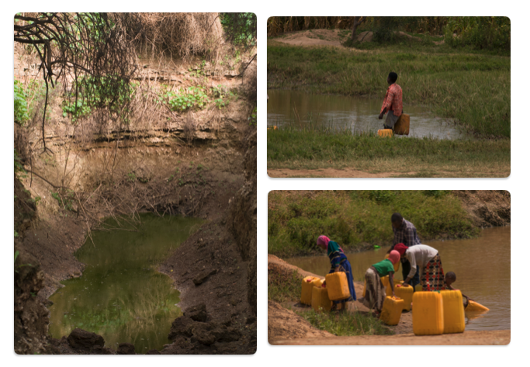

Figure 1 Water collection from open surface soruces

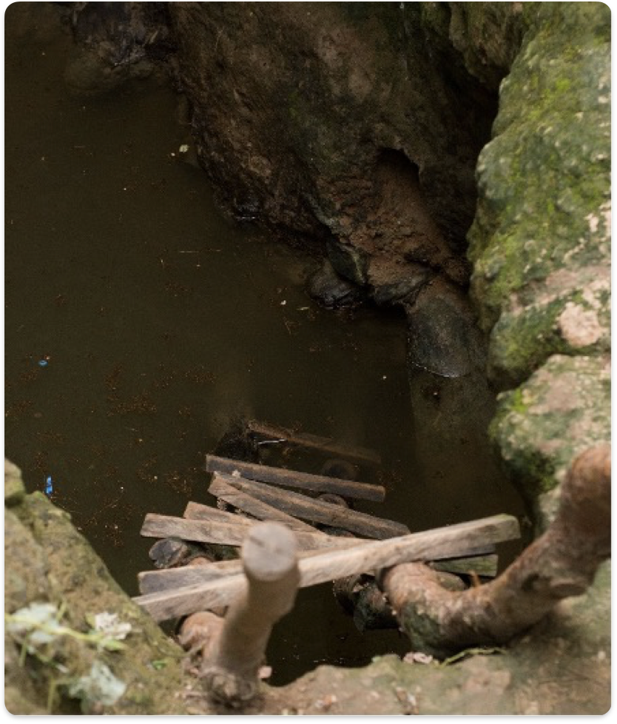

Figure 2 Unprotected borehole

Many health problems are linked to the use of unprotected water sources and unsafe water usage: a high incidence of diseases such as diarrhea, intestinal infections, and parasites. The project is addressed to supply safe drinking water to improve the hygiene, social, economic, and environmental issues related to the water consumption. Moreover, verifiable Carbon Dioxide (CO2) emission reductions will be achieved through reduced wood combustion and the need for water purification through boiling will be reduced. The project will raise awareness among the population regarding hygiene and contribute to sustainable development.

* + 1. Eligibility of the VPA under approved PoA

**Table 1 Eligibility for VPA inclusion as per PoA requirements**

|  |  |  |  |
| --- | --- | --- | --- |
| NO. | ELIGIBILITY CRITERION | DESCRIPTION/  REQUIRED CONDITION | DESCRIPTION OF THE VPA IN RELATION TO THE CRITERIA,  MEANS OF VERIFICATION AND SUPPORTING EVIDENCE  FOR INCLUSION |
| 1 | Types of  Project | Eligible projects shall  include physical action/implementation  on the ground. Preidentified eligible project types are identified in the Eligibility Principles and Requirements section. | The VPA provides access to clean water for household being thus a Community Service WASH activity.  In more details, the VPA includes the installation/rehabilitation of several sustainable water supply systems. |
| 2 | Location of Project | Projects may be located in any part of the world. | The project location is the United Republic of Tanzania. (refer to section A.2 of the PDD for detailed project area and boundary) and there are no mandatory operational schemes to reduce GHG emissions in any form (e.g., cap & trade, carbon tax etc.) in Tanzania, which based on section 3.1.1 of GS4GG GHG Emissions Reduction & Sequestration Product Requirements (Version 2.0) is an eligible host country. |
| 3 | Project Area, Project Boundary and Scale | The Project Area and Project Boundary shall be defined. Projects may be developed  at any scale although certain rules, requirements and limitations  may apply under specific Activity Requirements, Impact  Quantification Methodologies and Products Requirements.  In order to avoid double counting the Project shall not be included  in any other voluntary or compliance standards programme unless  approved by Gold Standard (for example through dual  certification). Also, if the Project Area overlaps with that of  another Gold Standard or other voluntary or compliance standard  programme of a similar nature, the project shall demonstrate that  there is no double counting of impacts at design and performance  certification (for example use of similar technology or practices  through which the potential arises for double counting or  misestimation of impacts amongst projects). | The project boundary is defined based on Methodology for Emission Reductions from Safe Drinking Water Supply (Version 1.0) and is limited to the United Republic of Tanzania (refer to section B.3 of the PDD). The project takes place inside the geographical boundaries of Maryara Region, Tanzania.  This project is not included by any other carbon standard neither voluntary or compliant.  The avoiding of the double counting is confirmed in two ways:  - the Project Area does not overlap with other Gold Standard or other voluntary or compliance standard programme of a similar nature  - Each project water system will be identified with unique gps coordinates of its location which enables the unique identification of the borehole to be part of this project.  The VPA is a small-scale project activity based on project scale defined under GS4GG Product Requirements.  Activity requirement: “Community Services Activity (CSA)”.  The VPA is an “End-use energy efficiency” project which is one of the pre-identified CSA project types noted in para 3.1.1. of the the “Community Services Activity Requirements (Version 1.2).” “End-use energy efficiency” projects are defined as project activities that reduce energy requirements as compared to baseline scenario without affecting the level and quality of services or products, where the end-user of the products and services are clearly identified and when the physical intervention is required at the user end. |
| 4 | Host Country Requirements: | Projects shall be in compliance  with applicable Host Country’s legal, environmental, ecological  and social regulations. | This project is in compliance with Tanzania’s legal, environmental, and social regulations. The project is actively contributing to the Host Country by reducing the GHG emissions, fuel consumption as well as economic and time savings to thousands of poor households.  Host country requires project registration at the national carbon registry as per 2023 amended regulation. |
| 5 | Contact Details: | As part of the Project Documentation the Project Developer shall provide (i) name and (ii) contact details of all Project Participants; AND in case of an organisation (iii) the  legal registration details and (iv) documentation by the governing  jurisdiction that proves that the entity is in good standing (defined as being a legal or other appropriate entity registered in or allowed to operate within the required jurisdiction and with no  evidence of insolvency or legal/criminal notices placed against it or any of its Directors). Gold Standard retains the right (at its own discretion) to refuse use of the Standard where reputational concerns are highlighted. | All the project participant information have been provided in Appendix 2. |
| 6 | Legal Ownership: | Full and uncontested legal ownership of any Products that are generated under Gold Standard Certification,  (for example carbon credits) shall be demonstrated. Where such  ownership is transferred from project beneficiaries this must be  demonstrated transparently and with full, prior and informed  consent (FPIC). Note that for certain Project types there is a requirement for full and uncontested legal land title/tenure to be demonstrated. These are contained within specific Activity or Product Requirements. All projects shall immediately report to Gold Standard any land title/tenure disputes arising. | The transfer of credit ownership from end-users and technology providers to the project developer is proved with written assertions signed by relevant representative.  Moreover, the credit ownership was also discussed during the stakeholder meeting and mentioned in the Project Summary provided to stakeholders. |
| 7 | Other Rights: | As well as legal title and ownership, the Project Developer shall also demonstrate where required uncontested legal rights and/or permissions concerning changes in use of other resources required to service the Project (for example, access rights, water rights etc.). Any known disputes or contested rights must be declared immediately to Gold Standard by the Project Developer and resolved prior to further project implementation in  affected areas | There are no disputes or contested rights that have been identified in relation to rights relevant to the project activity. |
| 8 | Official Development Assistance (ODA) Declaration: | All Project Developers applying for project activities located in a  country named by the OECD Development Assistance Committee’s ODA recipient list and seeking Gold Standard Certification for carbon credits shall declare the Official Development Assistance (ODA) support. The Project Developer shall follow the GHG Emissions Reduction & Sequestration Product Requirements and submit the declaration at the time of Design Certification. | It is confirmed that no Official Development Assistance (ODA) has been requested and none will be applied for the project activity. |

* + 1. Legal ownership of products generated by the VPA and legal rights to alter use of resources required to service the project

In line with the GS4GG Principles and Requirements (Version 1.2, Section 3.1), Istituto Oikos Onlus has full and uncontested legal ownership of the Verified Emission Reductions (VERs) that are generated under Gold Standard Certification has been demonstrated as follows:

- A legally-binding contractual agreement between CME/project developer (Carbonsink) and the project owner (Istituto Oikos Onlus) has been made. As part of this agreement, the ownership and selling rights of the emission reductions resulting from the project activity are clearly defined.

- The transfer of credit ownership from end-users and technology providers to the project developer will be proved with a written assertion.

* 1. **Location of VPA**

Host Country: United Republic of Tanzania

Region: Manyara Region

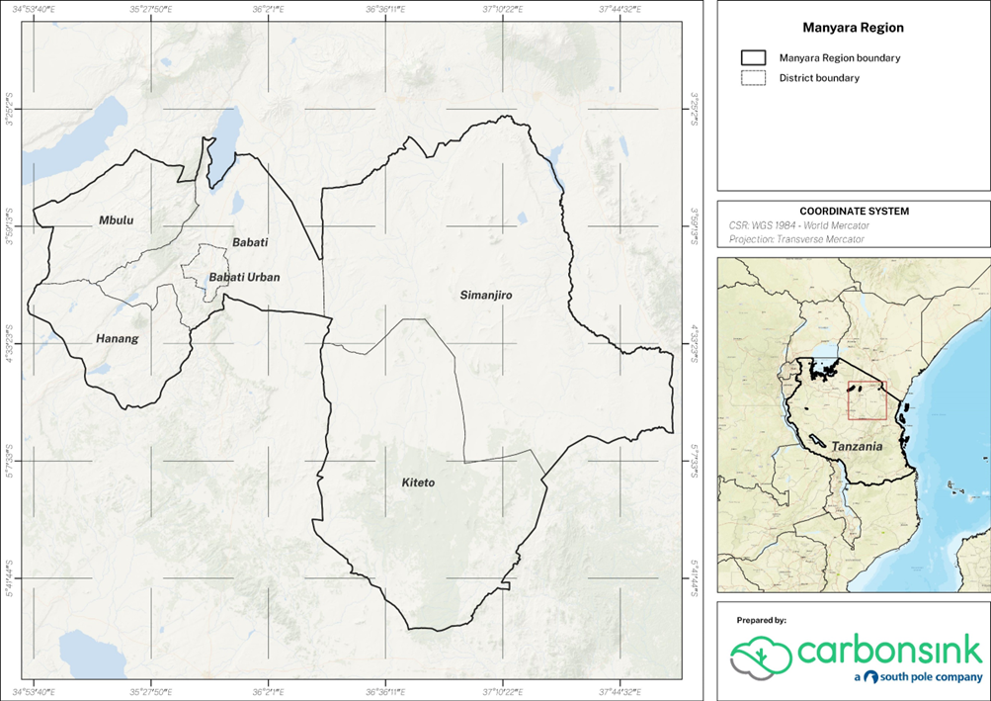

Figure 1 Location of Manyara Region in Tanzania

* 1. **Technologies and/or measures**

The project activity includes the installation/rehabilitation of several sustainable water supply systems based on solar powered pumps or gravity distribution systems (in which the water is transferred from capped springs to tanks located at elevated positions and from which the water is further piped into drinking water fountains).

The project involves both newly constructed boreholes and rehabilitated boreholes.

**Solar Pumping Systems**:

This category encloses all those systems that use underground water extracted by pumps powered by solar panels. These pumps pump water from the borehole to the storage tanks which serve water to the villages during the day and nighttime. Storage water is treated with a chlorination system.

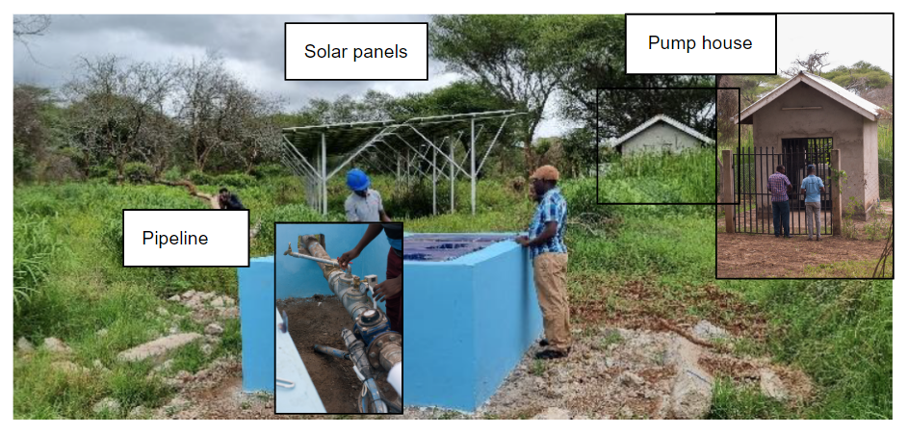

Figure 2 Example of solar pumping system in Loboirsiret village.

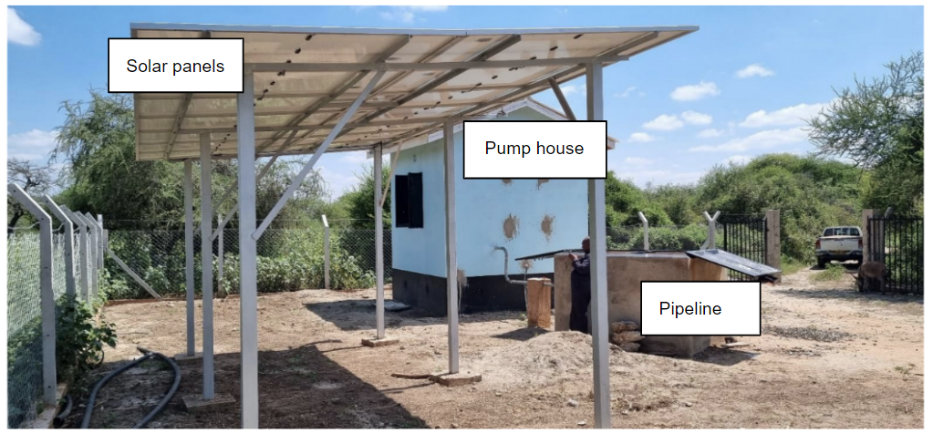

Figure 3 Example of solar pumping system in Ndedo water scheme

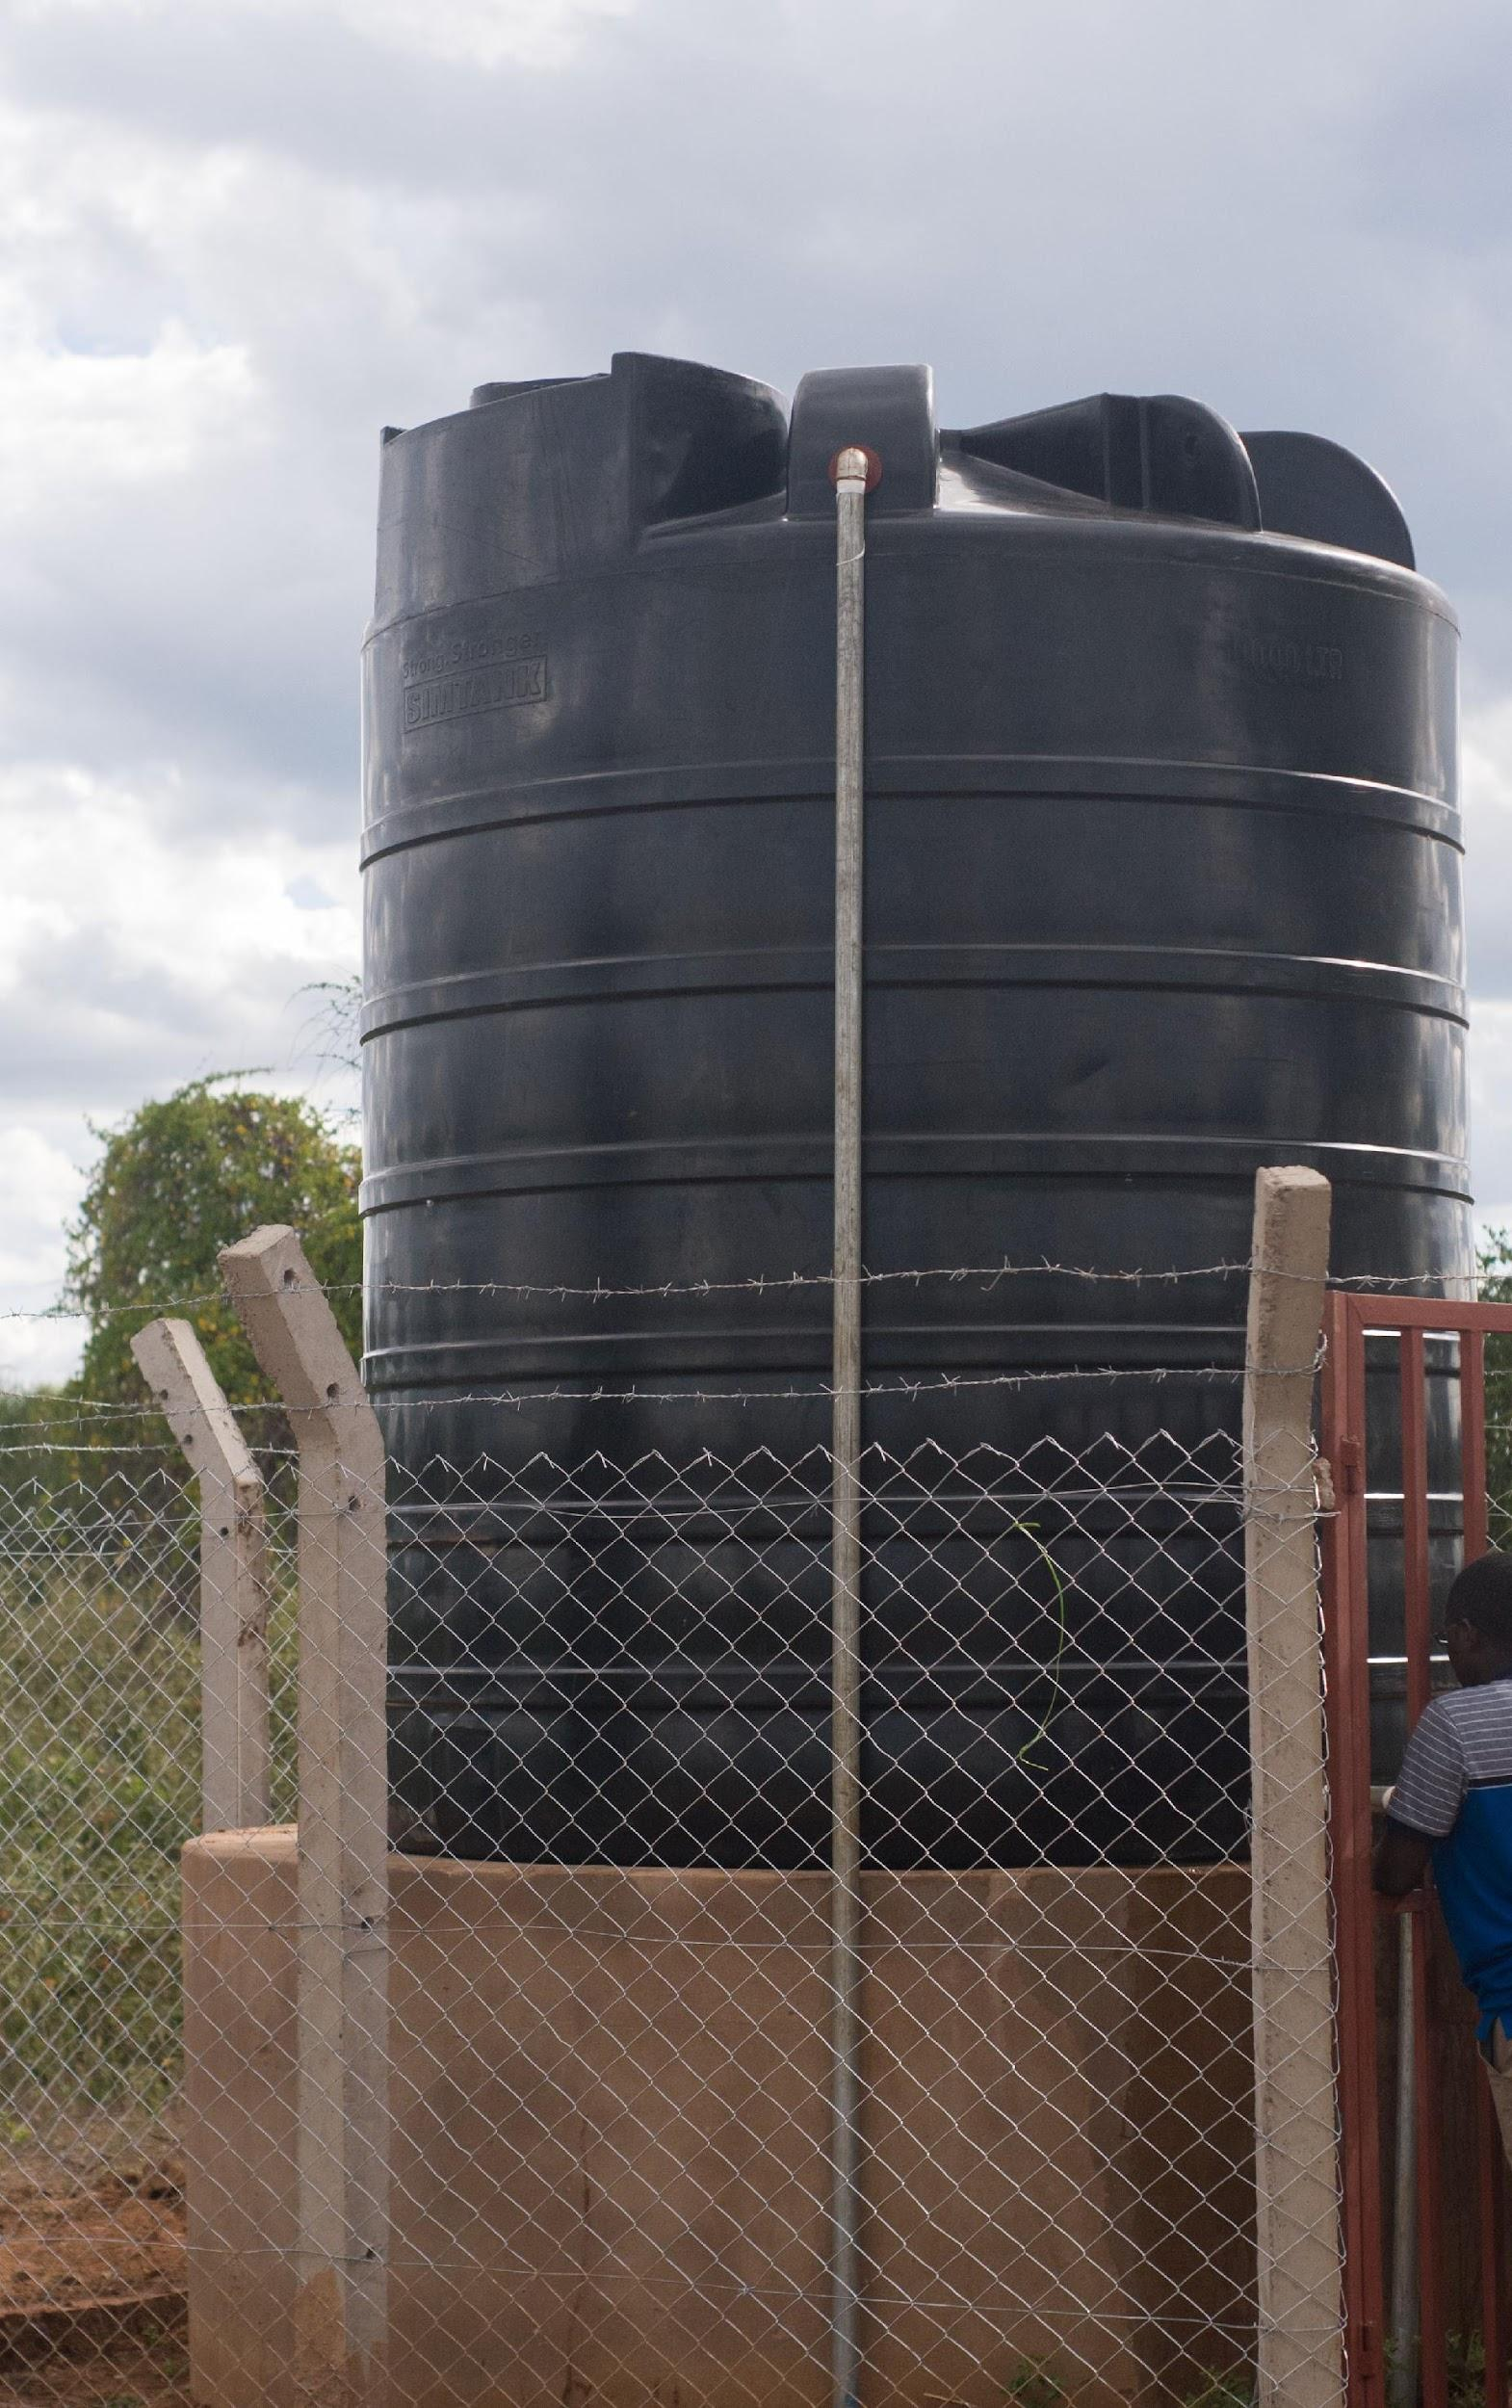

Figure 4 Storage Tank, Ndedo water scheme

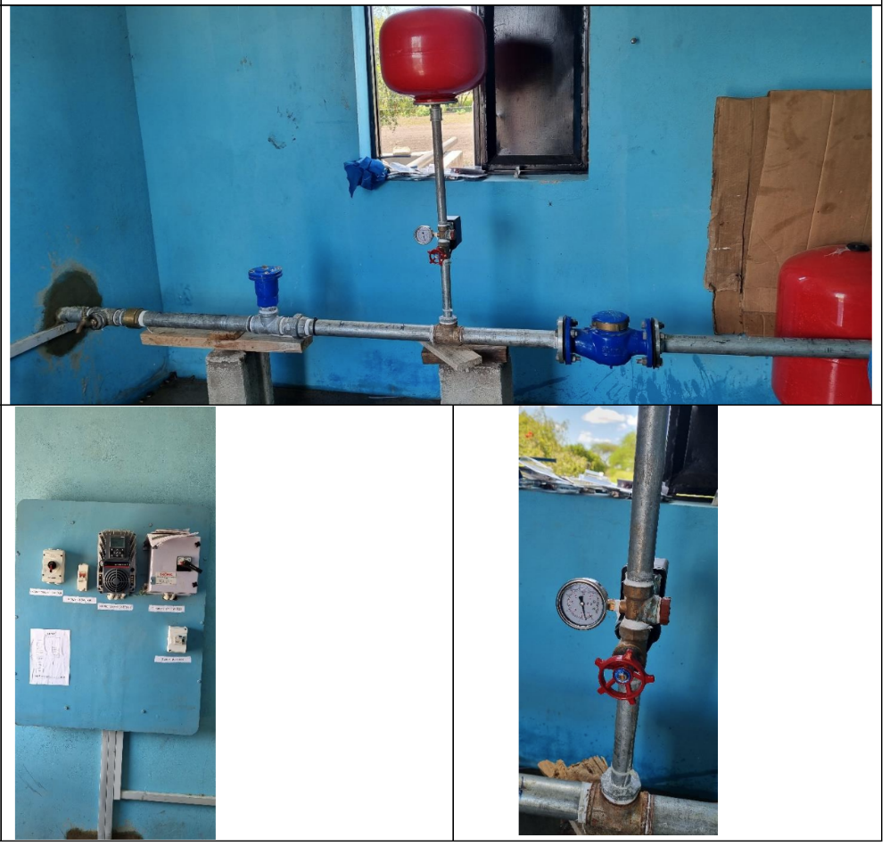

Figure 5 Pump house, Irkiushioibor water system

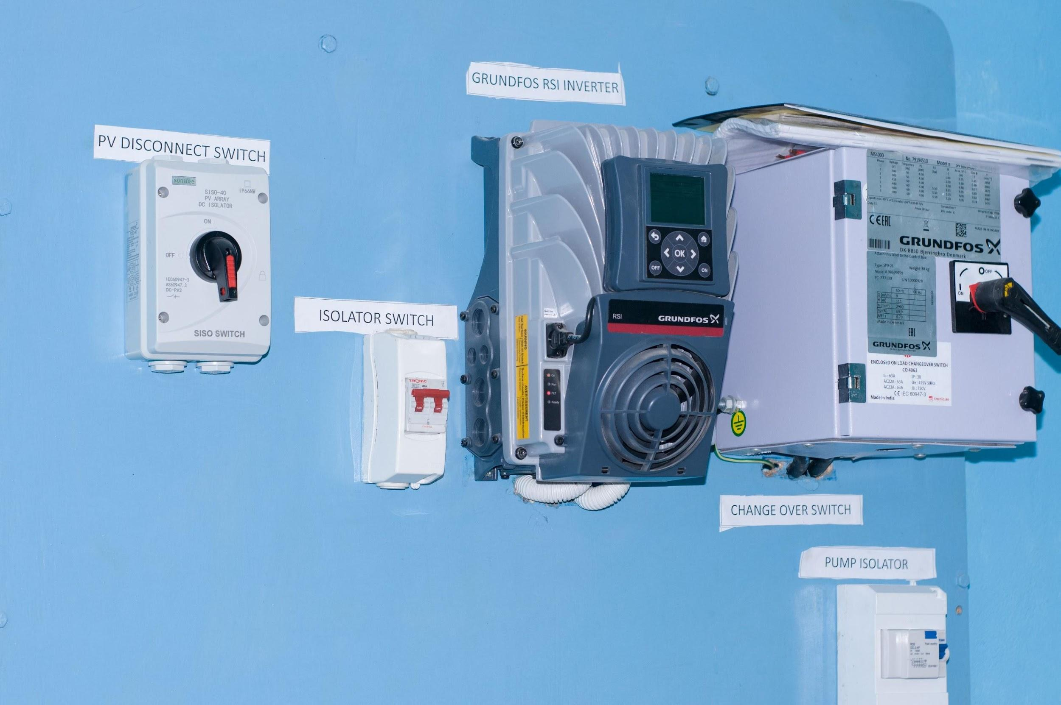

Figure 6 Example of energy system (solar panels and backup), Ndedo village

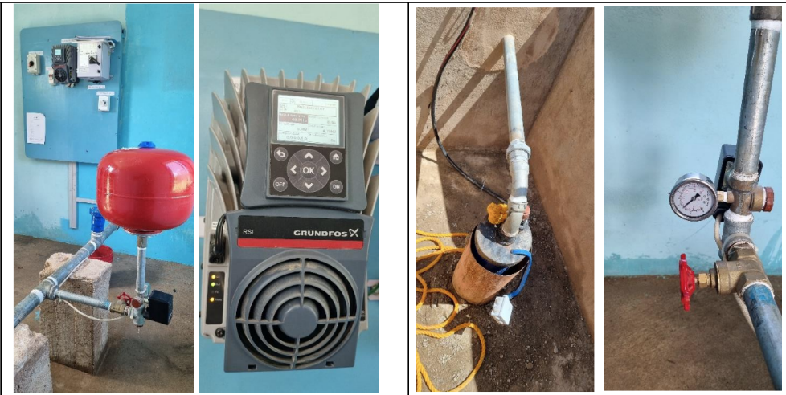

Figure 7 Pump house, Ndedo water system

**Gravity Water Systems**:

These systems use water originating from springs on mountains where water is collected and treated at intake and stored on different storage tanks. Storage water is treated with a chlorination system. For these systems no energy is required to distribute water to different parts of the village since the water uses gravity to flow from the source to the water points.

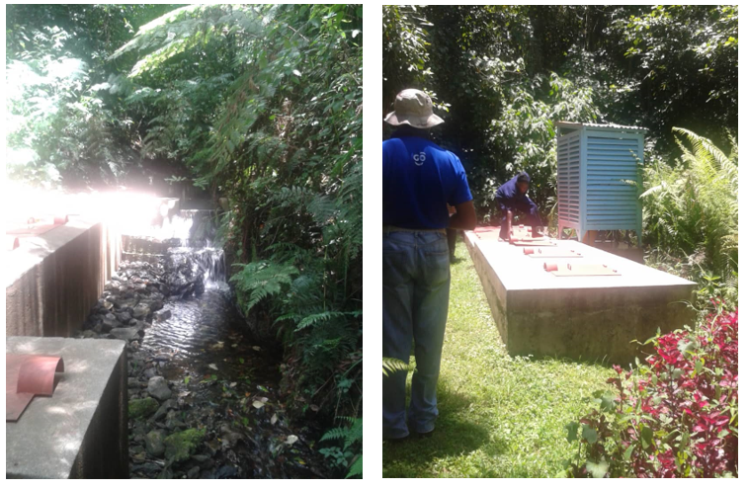

Figure 8 Example of gravity system

Table A.3.1 Summary of projects water systems

|  |  |  |  |  |  |  |
| --- | --- | --- | --- | --- | --- | --- |
| **Water scheme[1]** | **GPS Coordinates** | **HNs[2]** | **Technology** | **Crediting period start date** | **Operational Status** | **Type of system** |
| Namalulu | -4.34327 36.949831 | 1,341 | Solar | 28/10/22 | Fully operational | Rehabilitated |
| Loiborsiret | -3.58132 37.00458 | 2,685 | Solar | 28/10/22 | Fully operational | Rehabilitated |
| Sukuro | -4.04503 36.55929 | 158 | Solar | 28/10/22 | Fully operational | New |
| Loiborsoit B | -4.396361 37.477489 | 974 | Gravity | 29/10/22 | Fully operational | New |
| Lormolijoi | -3.71207 37.2939 | 826 | Solar | 29/10/22 | Fully operational | New |
| Irkiushboir | -4.840718 36.517675 | 771 | Solar | 30/10/22 | Fully operational | New |
| Kimotorok | -4.50578 36.28775 | 626 | Solar | 30/10/22 | Fully operational | New |
| Makame | -4.69291 36.67289 | 2,247 | Solar | 30/10/22 | Fully operational | New |
| Ndedo | -4.874538 36.792308 | 2,571 | Solar | 30/10/22 | Fully operational | New |
| Ngabolo | -5.11856 36.624549 | 1,337 | Solar | 10/12/22 | Fully operational | New |
| Shauri Moyo- Kisangaji - Maweni | -3.912796 35.688454 | 5,965 | Gravity | 23/03/23 | Fully operational | New |
| Arri - Harsha | -4.01162 35.26996 | 10,053 | Gravity | 23/03/23 | Fully operational | New |
| Tlawi - Jaranjar - Silaloda -Guneneda | -3.93755 35.488801 | 9,465 | Solar | 25/03/23 | Fully operational | New |
| Dongobesh | -4.072726 35.4572039 | 5,998 | Gravity | 25/03/24 | Fully operational | New |
| Erri | -4.06296 35.560178 | 2,579 | Gravity | 23/05/23 | Fully operational | New |

Table A.3.2 Technical specification Solar powered systems

|  |  |  |  |  |  |
| --- | --- | --- | --- | --- | --- |
| **Water scheme** | **Backup source of energy** | **AC Pump** | **Solar** | **Pump controler** | **manufacturer’s specifications and industry standards.** |
| Namalulu | N/A | GRUNDFOS SQF 1.2-2 | PolycrystallinSolar Panels 125W | GRUNDFOS CU 200 | European Standard |
| Loiborsiret | Generator | GRUNDFOS SP 30-17 15kW Pump <https://www.lenntech.com/grundfos/SPFAM/13A01917/SP-30-17.html?lang=English&utm_source=google&utm_medium=cpc&utm_campaign=834679918&utm_content=148380257947&utm_term=dsa-1948240757252&matchtype=&device=c&placement=&network=g&gad_source=1&gclid=Cj0KCQjwn7mwBhCiARIsAGoxjaJnjdesGeSr7l3WQNymhfgsjYEXgLsKXccBZjwt5FEvJ6CH-Q84ScQaAplrEALw_wcB> | JA solar panel. 550W MBB. JAM72S30  https://www.solarenergypoint.it/shop/ja-solar-jam72s30-550-mr-modulo-fotovoltaico-monocristallino-550w-half-cell | GRUNDFOS - RSI of 22kW  https://product-selection.grundfos.com/products/rsi/rsi-3x380-440v-ip66-22kw-46a-99044366?pumpsystemid=2306795826&tab=variant-specifications | European Standard |
| Sukuro | Generator | GRUNDFOS SP 7-31 4kW Pump  <https://product-selection.grundfos.com/products/sp-sp-g/sp/sp-7-31-98699184?pumpsystemid=2308825105&tab=variant-curves> | SUNTECH STP 335W - 24/Vfw  https://www.enfsolar.com/pv/panel-datasheet/crystalline/37668 | GRUNDFOS - RSI of 15kW  https://product-selection.grundfos.com/products/rsi/rsi-3x380-440v-ip66-15kw-31a-99044364?pumpsystemid=2306893678&tab=variant-specifications | European Standard |
| Irkiushboir | Generator | Grundfos Submerssible Pump with motor SP5A-17 (1.5kw,3PH)  https://www.lenntech.com/grundfos/SPFAM/5001917/SP-5A-17.html?lang=English&utm_source=google&utm_medium=cpc&utm_campaign=834679918&utm_content=148380257947&utm_term=dsa-1948240757252&matchtype=&device=c&placement=&network=g&gad_source=1&gclid=Cj0KCQjwn7mwBhCiARIsAGoxjaIkj9-1BDSLQ6LTjwiJxuWZt3T1b9j50x7vH87R5JkzoH8jT6Zu52MaAt8HEALw_wcB | SUNTECH STP 300W - 60/Wfh  https://www.gingroup.it/prodotto/suntech-superpoly-stp300-60-wfh/ | GRUNDFOS - RSI of 2.2kW  https://product-selection.grundfos.com/products/rsi/rsi-3x380-440v-ip66-22kw-56a-99044348?pumpsystemid=2306796448&tab=variant-specifications | European Standard |
| Kimotorok | N/A | LORENTZ PE C-SJ5-12  https://lorentzpumps.co.za/wp-content/uploads/2017/10/PS2-1800-C-SJ5-12-1.pdf | JA Solar Panel 460W - JAM72S20-455-470-MR  https://www.solarenergypoint.it/shop/ja-solar-jam72s20-460-mr-modulo-fotovoltaico-monocristallino-460w | LORENTZ Controller PS2-1800 1.8kVA  https://www.solaris-store.com/4473-controleur-lorentz-ps2-1800-18kva.html | European Standard |
| Makame (Tiakunini) | N/A | GRUNDFOS SQF 1.2-3  https://product-selection.grundfos.com/products/sqflex/sqf-12-3-96834838?pumpsystemid=2307182730&tab=variant-curves | Polycrystalline Solar Panels 125W  https://www.enfsolar.com/pv/panel-datasheet/crystalline/52588 | GRUNDFOS CU 200  https://product-selection.grundfos.com/products/cu-200-202-203?tab=products | European Standard |
| Makame (Tayei) | N/A | GRUNDFOS SQF 1.2-2  https://product-selection.grundfos.com/products/sqflex/sqf-12-2-95027328?pumpsystemid=2307666841&tab=variant-curves | Polycrystalline Solar Panels 125W  https://www.enfsolar.com/pv/panel-datasheet/crystalline/52588 | GRUNDFOS CU 200  https://product-selection.grundfos.com/products/cu-200-202-203?tab=products | European Standard |
| Ndedo | N/A | GRUNDFOS SP9-21 (4kw, 3 PH)  https://product-selection.grundfos.com/products/sp-sp-g/sp/sp-9-21-98699059?pumpsystemid=2308827905&tab=variant-curves | SUNTECH 450Wp GCL-M8/72H Monocrystalline PV  https://www.enfsolar.com/pv/panel-datasheet/crystalline/44310 | GRUNDFOS - RSI of 5.5kW  https://product-selection.grundfos.com/products/rsi/rsi-3x380-440v-ip66-55kw-12a-99044351?pumpsystemid=2307008892&tab=variant-specifications | European Standard |
| Ngabolo | N/A | GRUNDFOS SP 5A-60 5.5kW Pump  https://www.lenntech.com/grundfos/SPFAM/5261960/SP-5A-60N.html | JA Solar Panel 540W - JAM72S30 Monocrystalline  https://www.jasolar.com/uploadfile/2021/0706/20210706053524693.pdf | GRUNDFOS - RSI of 7.5kW  https://product-selection.grundfos.com/products/rsi/rsi-3x380-440v-ip66-75kw-16a-99044352?pumpsystemid=2307116450&tab=variant-specifications | European Standard |

Table A.3.3.Capacity and lifetime solar systems

|  |  |  |  |  |
| --- | --- | --- | --- | --- |
| **Water scheme** | **Capacity (rated or calculated flow rate) - m3/h)** | **lifetime Pump (Years)** | **lifetime PV modules (Solar Generators) - Years** | **lifetime Pump Controller (Years)** |
| Namalulu |  |  |  |  |
| Loiborsiret | 15 | 7 | 20 | 10 |
| Sukuro | 7 | 7 | 20 | 10 |
| Irkiushboir | 5 | 7 | 20 | 10 |
| Kimotorok | 5 | 7 | 20 | 10 |
| Makame (Tiakunini) | 2.54 | 7 | 20 | 10 |
| Makame (Tayei) | 1.29 | 7 | 20 | 10 |
| Ndedo | 9 | 7 | 20 | 10 |
| Ngabolo | 4.57 | 7 | 20 | 10 |

Table A.3.4. Technical specification Gravity Systems

|  |  |  |
| --- | --- | --- |
| **Water scheme** | **Tank (m3)** | **Capacity (rated or calclulated flow rate) - m3/h)** |
| Loiborsoit B | 50 | 15 |
| Lormolijoi | 225 | 25 |
| Tlawi - Jaranjar - Silaloda -Guneneda | 50 | 12.91 |
| Dongobesh | 180 | 52.4 |
| Shauri Moyo- Kisangaji - Maweni | 100 | 36.5 |
| Arri - Harsha | 492 | 31.8 |
| Erri | 100 | 14 |

|  |  |  |  |
| --- | --- | --- | --- |
| **Boarding school[3] name** | **Village** | **District** | **Number of students** |
| Notre Dame Osotwa Pre and primary school, Loiborsiret Secondary school. | Loiborsiret | Simanjiro | 609 |
| Eng'eno Secondary school. | Sukuro | Simanjiro | 167 |
| Ndedo primary and secondary schools. | Ndedo | Kiteto | 1,564 |
| Makame primary school | Makame | Kiteto | 783 |
| Tlaw Secondary School | Tlawi | Mbulu | 512 |
| Lea Primary School | Dongobesh | Mbulu | 450 |
| Dongobesh School of Deaf | Dongobesh | Mbulu | 79 |
| Dongobesh Secondary School | Dongobesh | Mbulu | 292 |

* 1. **Scale of the VPA**

The VPA is a small-scale project activity based on project scale defined under GS4GG Product Requirements.

Activity requirement: “Community Services Activity (CSA)”.

The VPA is an “End-use energy efficiency” project which is one of the pre-identified CSA project types noted in para 3.1.1. of the the “Community Services Activity Requirements (Version 1.2).” “End-use energy efficiency” projects are defined as project activities that reduce energy requirements as compared to baseline scenario without affecting the level and quality of services or products, where the end-user of the products and services are clearly identified and when the physical intervention is required at the user end.

* 1. **Funding sources of VPA**

The project is funded by private sources of the Project Developer and with the initial financial contribution of AICS (Italian Agency for Development Cooperation). There are no official development assistance (ODA) funding for this project activity in exchange of the carbon credits. Please see the signed ODA declaration uploaded to SustainCERT

platform.

## SECTION B. APPLICATION OF APPROVED GOLD STANDARD METHODOLOGY (IES) AND/OR DEMONSTRATION OF SDG CONTRIBUTIONS

**B.1 Reference of approved methodology (ies)**

Emission Reduction from safe drinking water supply version 1.0

**B.2 Applicability of methodology (ies)**

The choice of the selected methodology is justified by demonstrating that the project meets each applicability condition of the applied methodology (see the below table).

Table B.2.1 Applicability of Methodology for Emission Reductions from Safe Drinking Water Supply (Version 1.0).

|  |  |  |
| --- | --- | --- |
|  |  |  |
|  | **Methodology applicability requirement** | **Justification regarding this VPA** |
| a | Eligible household water treatment technologies (HWT), institutional water treatment technologies (IWT), and community level water treatment technologies (CWT) include bleach/chlorine, water filter (ceramic, sand, composite, membrane, etc.), UV disinfection, etc. | The project includes the construction/rehabilitation of sustainable water supply systems which follow under the definition of Community level water treatment technologies.. (CWT) defined in Section 1 of the applied methodology.  Each project water systems is equipped with chlorination system. |
| b | Eligible community water supply technologies (CWS) include new installation of new borehole hand-pumps, borehole hand-pumps rehabilitation, solar powered drinking water pumps, etc. Water pumps powered by fossil-fuel engines are not eligible, with the exception of backup fossil–fuel engines that are used for no more than 10% of operating hours. | The project includes the construction/rehabilitation of community water supply technologies.   The technologies are based on solar powered pumps or gravity distribution systems (i.e., “zero emission” technologies). Backup fossil fuel engines might be used for no more than 10% of operating hours.  Regular measurements will be performed to check the percentage of used energy. |
| c | All projects involving CWT and CWS technologies must also include ongoing maintenance and repair of the project technology. | The local representative will consistently maintain a log of operations and maintenance activities |
| d | Where the project involves the rehabilitation of an existing technology, the project developer shall provide evidence that the existing technology is non-operational and that there is no planned maintenance or repair for at least 3 months after the date it became non-operational. | Supporting evidence will be provide in case of rehabilitation systems. |
| e | This methodology allows for project activities to include safe water treatment and/or supply technologies implemented for end-users in households, and/or commercial premises such as shops or institutional premises including half or full day/boarding schools, prisons, army camps & refugee camps. | Community level water treatment technologies and Institutional water treatment technologies (boarding schools). |
| f | In cases where the safe water is retrieved at the CWT or CWS location, the water in its improved form shall be available within a distance of 1 km or less from the end-users, as demonstrated by satellite imaging or GPS coordinates of each CWT or CWS location. Alternatively, as a proxy, a total collection time of 30 minutes or less for a round trip, including queuing, using the travel modes of walking or pedaling may be demonstrated. | The water systems are available within a distance of 1 km or less from the end-users. GPS Coordinates of each water systems will be provided.. |
| g | Project technology performance level (HWT and IWT): It shall be  demonstrated based on report of laboratory testing or official notification that the project technology or equipment achieves either (i) the performance target classification 3-star or 2-star level, meaning “Comprehensive Protection,” as per the WHO International Scheme to Evaluate Household Water Treatment Technologies (World Health Organization, 2011) or (ii) compliance with the national standard or guideline for household drinking water treatment technology; if no national guideline or standard is available, then the project technology shall comply with the WHO International Scheme requirements as per (i) (parameter SDWS 2). | N/A |
| h | Project technology performance level (CWT and CWS): For each individual CWT or CWS, it shall be demonstrated at the start of each crediting period with water quality testing reports that the water directly supplied by the project water technology/source achieves both:  i. microbial quality in line with either (i) national standards or guidelines for microbial quality of drinking water, or in the absence of such requirements, (ii) the guideline values for verification of microbial quality from the Guidelines for drinking-water quality (Table 7.10, WHO, 2017); and  ii. with (i) national standards or guidelines on priority chemical contamination and physical and aesthetic aspects, or in the absence of such requirements, (ii) international standards or guidelines on priority chemical contamination11 and physical and aesthetic aspects. | For each water systems, water quality testing reports will be carried in line with national requirements. |
| i | The project must conduct annual water hygiene education campaigns for the end-users. | Hygiene Campaigns will be performed on a yearly basis. |
| j | A project applying this methodology may make SDG claims if relevant monitoring parameter(s) is included in the monitoring plan to demonstrate and confirm the project’s contributions to SDGs. | The project developer/CME will  capture all the SDG indicators which is relevant to this project through monitoring in Household. The monitoring will be done using a detailed questionnaire. |

B.3 VPA boundary

The project boundary as specified in section 3.1 of the applied GS methodology includes:

|  |  |
| --- | --- |
| 1. the physical, geographical sites of the low- or zero-greenhouse gas emitting technologies to treat/supply safe drinking water installed by the project activity, | GPS coordinates of each water supply systems and relative water distribution points have been identified. |
| 1. any back-up engines or other equipment using fossil-fuel related to the low-greenhouse gas emitting technologies, | Some solar powered systems has a backup energy systems using fossil fuel.  The amount of energy provided by this source is constantly monitored.  The number of days in which the backup technology will be used for more than 10% of total operating hours during the day will not take into consideration for emission reduction calculation. |
| 1. the electricity grid, in the case electricity is used by the project, and | Some solar powered systems has a backup energy systems using electrical grid.  The amount of energy provided by this source is constantly monitored.  The number of days in which the backup technology will be used for more than 10% of total operating hours during the day will not take into consideration for emission reduction calculation. |
| 1. the household, commercial and institutional buildings where the end users of safe water provided by the project are located. | GPS coordinates of each end-users have been identified. |

The sources and gases included in the project boundary are described in the below

table.

|  |  |  |  |  |
| --- | --- | --- | --- | --- |
| Source | | GHGs | Included? | Justification/Explanation |
| **Baseline scenario** | Emissions from wood fuels utilized for obtaining safe drinking water displaced due to project activity | CO2 | Yes | Major source of emissions |
| CH4 | Yes | Minor source of emissions |
| N2O | Yes | Minor source of emissions |
| Emissions from fossil fuels utilized for obtaining safe drinking water displaced due to project activity | CO2 | Yes | Major source of emissions |
| CH4 | No | Excluded for simplification |
| N2O | No | Excluded for simplification |
|  |  |  |
| **Project scenario** | Emissions from electricity for operating project water supply/treatment technology | CO2 | Yes | Limited electrical energy may be required |
| CH4 | No | Excluded for simplification |
| N2O | No | Excluded for simplification |
|  |  |  |
| Emissions from fossil fuels for operating project water supply/treatment technology | CO2 | Yes | Limited fuel energy may be required |
| CH4 | No | Excluded for simplification |
| N2O | No | Excluded for simplification |
|  |  |  |

**Eligibility and Inclusion Criteria**

(As per Programme of Activity Requirements V2.1 Section 4.12)

|  |  |
| --- | --- |
| a. Geographical boundaries of the VPA consistent with that of the PoA | The boundary for the PoA in terms of geographical area is defined as the territorial boundary of Mozambique and United republic of Tanzania.  The VPA is implemented in the United Republic of Tanzania within the geographical boundaries of the PoA |
| b. Conditions to avoid double counting of GHG emission reductions or net  anthropogenic GHG removals, such as unique identifications of product and end user locations | The potential for double counting is considered negligible since :  1)Each product (i.e., safe water system) can be easily identified through unique location of each water distribution point (table A.3.1).  2) All the end-users involved in the project have been registered across the project areas. |
| c. Conditions to check the start dates of VPA through documentary evidence | The start date of the VPA is the date that the first unit is installed. For this reason relative document prooving the date of the first commitment for the construction of the first water system. |
| d. Conditions to ensure compliance with the applicability of the applied  methodologies, the applied standardised baselines and the other  applied methodological regulatory documents | The VPA-DD includes information on how it complies with all the applicability criteria of the methodology “Emission Reduction from safe drinking water supply”, version 1.0. A detailed justification is provided in section B.2. |
| e. Conditions to ensure that VPA meet the requirements for demonstration of additionality | The VPA is located within the PoA geographical boundaries of Tanzania which is a LDC as per United Nation’s list of Least Developed Countries. Therefore,the VPAs can be deemed automatically additional. |
| f. Condition to ensure that the real case VPA and its regular VPAs meet  the applicability criteria of selected methodology of combination of  methodologies | The VPA-DD of real case includes information on how it complies with all the applicability criteria of the methodology “Emission Reduction from safe drinking water supply”, version 1.0. A detailed justification is provided in section B.2. VPA-DDs of regual case will include the same. |
| g. Conditions to ensure that real case and its regular VPAs systematically  demonstrate additionality in accordance with Principles & Requirements. | The real case VPA and relative regular case VPAs are located within the PoA geographical boundaries of Tanzania which is a LDC as per United Nation’s list of Least Developed Countries. Therefore, the VPAs can be deemed automatically additional. |

**B.4. Establishment and description of baseline scenario**

Under the applied methodology for emission reduction from safe drinking water supply- version 1.0, the project’s objective is to reduce or avoid GHG emissions from boiling unsafe drinking water in the baseline and to supply drinking water that is safe for consumption when it enters the project households.

As per para 3.4.1 of the methodology, for users that boil unsafe water for drinking in the pre-project scenario, the general baseline scenario is that users would have boiled water for drinking in the absence of the project activity. The target population for this VPA are all users of either three stone fired wood stove or traditional biomass cookstove. The biomass used as fuel for cooking shall be ascertained for calculating baseline emissions.

As per para 3.4.3 of the methodology, for household end-users currently drinking unsafe water, the principles of suppressed demand are applied, such that the general baseline scenario is assumed to be that users would have boiled water for drinking in the absence of the project activity. In line with the paragraph 3.4.2 of the applied methodology, for the case of end-users currently drinking unsafe water because e.g. energy poverty barriers result in less than the minimum required amount of safe drinking water, the principles of suppressed demand are applied and the baseline is setas a proxy technology (water boiling of an adequate quantity of drinking water) basedon the standard of living achieved by peers (adequate supply of safe drinking water).

**Selection and justification of baseline scenario:**

The baseline scenario has been defined based on the baseline study conducted in September 2022 in the project area. The baseline survey has been carried out to document the drinking water sources and/or treatment technologies available and used in the project boundary, the baseline stove or water boiling technologies and technologies’ thermal efficiency used in the project boundary and the baseline cooking fuels used for water boiling in the project boundary.

As per the methodology, the baseline scenario selection and justification are established in the following steps as part of the conduct baseline study (full description of the baseline selection and justification has been made available in a separate document “Baseline Report 2022”[4]).

The main outcomes regarding drinking water sources and/or treatment technologies, efficiency of water boiling systems and baseline fuels of the baseline studies are summarized below.

Water source preferences vary widely based on seasonality. Rainwater collection from unsafe above-ground water sources is the most common practice during the rainy season. Meanwhile, unprotected boreholes have been used for fetching water during the dry season. The consumption of drinking water per person varies from 7 to 8 liters per day. While the water used for other purposes is on average 22.5 liters per day during the rainy season and is drastically reduced during the driest days, reaching 14 liters per person per day. All the respondents declared that drinking water from the baseline sources is not acceptable. Most of the household treat unsafe water before drinking, among these boiling using three stone fire is the most common practice.

The following baseline studies has been made:

**A. Baseline Non-Renewable Biomass (NRB) assessment, if biomass is one of the baseline fuels**

As the biomass is the baseline fuel of the project, the fractional non-renewability of biomass needs to be established.

As the biomass is the baseline fuel of the project, the fractional non-renewability of biomass needs to be established. The following national default value provided by the CDM Executive Board and endorsed by the DNA of the host country Tanzania is used in this project.

The value of fNRB is fixed ex-ante for entire crediting period even though the project activity may choose to update the fNRB during the crediting period.

Country Default Value of fNRB

United Republic of Tanzania 82.77% [5]

**B. Target population characteristics**

The baseline survey has been made with in person interviews with a robust sample of targeted end-users without project technologies that are representative of end-users targeted in the project activity. The baseline survey was made to provide information on target population characteristics, baseline technology use, fuel consumption, leakage and sustainable development indicators. Moreover, it is used for determining the baseline access to safe drinking water and the suppressed demand situation in the project area. The baseline report described gives full details of the implemented baseline studies and the results .

The survey was carried out following the below guidelines for minimum sample size and was tailored to gather the following data:

Sample sizing

- Group size > 1000: Minimum sample size 100

Data collected

- Address or location and telephone number (mobile or landline where possible)

- The number of people served by the baseline technology and typical usage patterns and tasks (e.g. commercial, institutional, domestic, etc.)

- Types of baseline technologies used and estimated frequency

- Types of fuels used and estimated quantities

- Seasonal variations in baseline technology and fuel use

- Sources of fuels (purchased or hand-collected, etc.) and prices paid or effort made (e.g. walking distances, persons collecting, opportunity costs)

- Sources for water supply, effort made and seasonal variations

- Indicators of suppressed demand (e.g. reasons for not purifying, eventual barriers, preferred purification methods in case the barriers would not exist)

- Renewability and non-renewability indicators as required by Annex 1 of the applied methodology

- Number of households and family members and name of household representatives within the comprehensive baseline census

**B.5. Demonstration of additionality**

The table below is only applicable if the proposed project is deemed additional, as

defined by the applied approved methodology or activity requirement or product

requirement.

|  |  |
| --- | --- |
| Specify the methodology, activity requirement or product requirement that establishes deemed additionality for the proposed project (including the version number and the specific paragraph, if applicable). | As demonstrated in the Gold Standard for the Global Goals Community Services Activity Requirements section 4.1.9 - Projects that meet any of the following criteria are considered as deemed additional and therefore are not required to prove Financial Additionality at the time of Design Certification:  1. (a) Positive list (Annex B)  2. (b) Projects located in LDC, SIDS,LLDC  3. (c) Micro-scale projects |
| Describe how the proposed VPA meets the criteria for deemed additionality. | (a) Positive list (Annex B):  As per section 3.6.2 of the applied GS methodology, the amount of energy required to boil 1 L of water is 360.83 kJ/L. According to equation 7 and 8 of section B.6 of the PDD, the annual quantity of safe water provided by each of the project water purifier (solely composed of isolated units of the project activity) can be calculated as: Up,y (Usage rate of the project technology by premises type p during year y)*QPWp (Volume of drinking water per person per day) y)*DPp,y (Days the project technology is present for end-users in the premises p in year y)=90%*5.5*365= 1,806.75L.  The weighted average efficiency of the baseline stove for water boiling is 10%. Annual thermal energy savings can be calculated as 360.83kJ/L*1,806.75L/1,000,000/10%=0.065GJ=0.054 MWhth , which is less than 1,800 MWhth (600MWh). Besides, End-users of the water purifiers are households. The project activity falls under section 1.1.3 of Annex B Positive list of GS4GG Community Services Activity Requirements (Version 1.2). As per section 4.1.9(a) of GS4GG Community Services Activity Requirements (Version 1.2), the project considered as deemed additional  (b) Projects located in LDC, SIDS,LLDC  The host country where the project is located LDC[6], United Republic of Tanzania. |

B.5.1 Prior Consideration

According to Gold Standard’s Principles and Requirements (version 1.2), Retroactive projects shall submit the required documents for preliminary review (time of first submission) within one year of the project start date. Retroactive Project submitted at a date later than one year from the project start date will not be eligible for Gold Standard certification.

The project start date is 13/07/2021 and PP has submitted the required documents for preliminary review on 30/06/2022 which is within one year of the project start date. Therefore, the project is eligible for Gold Standard certification.

B.5.2 Ongoing Financial Need

The project is neither under Design Certification Renewal nor required to demonstrate financial additionality. Ongoing financial need is not applicable.

**B.6. Sustainable Development Goals (SDG) outcomes**

Relevant Target/Indicator for each of the three SDGs

|  |  |  |
| --- | --- | --- |
| SUSTAINABLE DEVELOPMENT  GOALS TARGETED | MOST RELEVANT  SDG TARGET | SDG IMPACT |
| **INDICATOR (PROPOSED OR SDG INDICATOR)** |
| SDG 13 Climate Action (mandatory) | 13.2 Integrate climate change measures into national policies, planning and strategies | Emissions Reductions |
| SDG 6: Clean Water and Sanitation | 6.1: By 2030, achieve universal and equitable access to safe and affordable drinking water for all | Number of households with access to improved sources of safe water |
| SDG 8: Increased employment growth | 8.5 By 2030, achieve full and productive employment and decent work for all women and men, including for young people and persons with disabilities, and equal pay for work of equal value | Total number of jobs created |
|  |  |  |

B.6.1. Explanation of methodological choices/approaches for estimating the SDG Impact

**Proposed approach to estimate SDG 13**

The outcome of the SDG 13 (Climate Action) will be measured as reduced greenhouse

gas emissions as tonnes of CO2e applying the GS methodology Emission reductions from Safe Drinking water supply v 1.0. The SDG 13 outcome will be certified as “Certified SDG 13 Impacts” allowing the generation of carbon credits (GS VERs).

**Baseline Emissions**

In line with the applied methodology “GS MS Methodology for Emission Reductions from Safe Drinking Water Supply v1.0”, the baseline emission factor is calculated as follows:

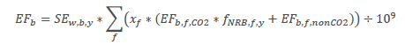

Where:

|  |  |
| --- | --- |
| EFb | Emission factor for the use of fuel to obtain safe water in the baseline (tCO2e/L) |
| SEw,b,y | Specific energy required to boil water (kJ/L), to be calculated as per the paragraph below |
| xf | Proportion of fuel *f* used in the baseline (fraction determined based on an energy basis) |
| EFb,f,CO2 | CO2 emission factor from use of fuel *f* (tCO2/TJ) |
| EFb,f,nonCO2 | Non-CO2 emission factor arising from use of fuel *f*, when the baseline fuel *f* is biomass or charcoal (tCO2e/TJ). This parameter is omitted when *f* is a fossil fuel |
| fNRB,f,y | Fractional non-renewability status of woody biomass fuel during year *y* (fraction). For biomass, it is the fraction of woody biomass that can be established as non-renewable. This parameter is omitted when *f* is a fossil fuel. |
| f | Index for baseline fuel types |

The specific energy required to boil water using the baseline technology (SEw,b,y) is determined as follows, by calculating the energy input required to obtain 1 L of boiling water, including boiling and vaporization losses16, taking into account default or measured stove efficiency.



Where:

|  |  |
| --- | --- |
| 360.83 | Default amount of energy required to obtain 1 L of water after 5 minutes of boiling from a first principles approach17 kJ/l |
| ηwb | Efficiency of the stoves for baseline water boiling (%). Weighted average of baseline stove types. |

The baseline emissions are calculated as follows:

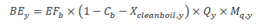

Where:

|  |  |
| --- | --- |
| BEy | Baseline emissions from the use of fuel to obtain safe water in the baseline (tCO2e) |
| Cb | Proportion of project end-users who in the baseline were already using a safe water supply that did not require boiling (%) |
| Xcleanboil,y | Proportion of project end-users that boil safe water in the project year *y* (%) |
| Qy | Quantity of safe drinking water provided by the project in year *y* (L) |
| Mq,y | Modifier for the water quality in year y |

The quantity of safe drinking water provided by the project is calculated using Method 1 according to Section 3.6.4 of the applied methodology.

In the case of CWT and CWS, the quantity of safe drinking water provided by the project Qy is determined as follows:



Where:

|  |  |
| --- | --- |
| Qm,y | Monitored quantity of safe water provided by the project in year *y* (L) |
| Qpop,y | Quantity of safe drinking water that could be consumed by project end-users in year *y* (L) |

Quantity of safe drinking water shall be calculated as follows:



Where:

|  |  |
| --- | --- |
| HHp,y | Number of premises type *p* served by the project in year *y* |
| HNp,y | Number of individuals per premises type *p* (e.g. household, school) in year *y* |
| QPWp | Volume of drinking water per person per day for premises type *p* (L). Apply the default value or monitored value through water consumption field tests in the project scenario, capped at 5.5 L per person per day |
| DOp,y | Days the project technology is operational for end-users in premises *p* in year *y* |

**Project emissions**

According to the applied methodology the project emissions may result from the operation of new low-emission water treatment technologies. Project emissions are calculated as follows:

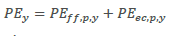

Where:

|  |  |
| --- | --- |
| PEy | Project emissions in year *y* (tCO2) |
| PEff,p,y | Project emissions from fossil fuel use in year *y* (tCO2) |
| PEec,p,y | Project emissions from electricity use in year *y* (tCO2) |

Project emissions from fossil fuel use are determined as follows:

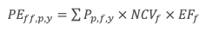

Where:

|  |  |
| --- | --- |
| 𝑃𝑝,𝑓,𝑦 = | Quantity of fossil fuel f that is consumed in the project during year y (mass or volume units) |
| 𝑁𝐶𝑉 𝑓 = | Net calorific value of fossil fuel f (TJ/fuel units) |
| 𝐸𝐹 𝑓 = | Emission factor of fossil fuel f (tCO2/TJ) |

Project emissions from electricity use are determined as follows:

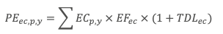

Where:

|  |  |
| --- | --- |
| 𝐸𝐶𝑝,𝑦 = | Quantity of electricity that is used by the project during year y (kWh) |
| 𝐸𝐹 𝑒𝑐 = | Emission factor associated with the electricity use  (tCO2/kWh) |
| 𝑇𝐷𝐿𝑒𝑐 = | Transmission and distribution losses associated with the  electricity use (%) |

**Leakage emissions**

Where relevant, leakage relating to the non-renewable woody biomass shall be assessed as follows. Other types of leakage are excluded for simplification.

Leakage emissions, LEy, shall be calculated as follows:

1. First, the project developer must evaluate, ex-ante, the following potential sources of leakage and provide an evidence-based description and preliminary quantification of each potential source and its relevance for the project:
   1. Members of the population who do not participate in the project, and previously used lower emitting energy sources, instead use the non-renewable biomass saved under the project activity.
   2. The project significantly reduces the NRB fraction within an area where other GHG mitigation project activities account for NRB fraction in their baseline scenario.
   3. The project population compensates for loss of the space heating effect of water boiling by adopting some other form of space heating or by retaining some baseline wood fuel-burning practices.

Leakage risks deemed very low can be ignored as long as the case for their insignificance is substantiated.

1. Second, for each source for which the leakage assessment expects an increase in non-renewable biomass fuel consumption by non-project households/users attributable to the project activity, then calculations must be undertaken to account for the leakage from this source. Leakage is either calculated as a quantitative emissions volume (tCO2e) or as a percentage of total emission reductions. The project documentation shall include a projection of leakage emissions based on available data and information. The monitoring plan must include monitoring parameters to be registered during the leakage investigation every two years to populate the leakage calculation.
2. Third, the project developer must conduct a leakage investigation every two years using relevant methods. For example, surveys to determine parameters for the leakage calculation may be combined with project monitoring surveys, as is applicable.

If the ex-ante evaluation shows that leakage emissions are less than 5% of total emission reductions, then no monitoring is needed, and emission reductions simply shall be adjusted 5% down. In this case, the sources and magnitude of leakage emissions must be reassessed at the time of crediting period renewal.

**Emission reductions**



Where:

|  |  |
| --- | --- |
| ERy | Emission reductions in year y (t CO2e/yr) |
| BEy | Baseline emissions in year y (t CO2e/yr) |
| Pey | Project emissions in year y (t CO2e/yr) |
| LEy | Leakage emissions in year y (t CO2e/yr) |

**Proposed approach to estimate SDG 6**

Total number of premises meeting “safely managed drinking water services” calculated as follows:

HHsafe= HH* Mq,y

Where:

HHsafe: total number of households meeting “safely managed drinking water services” HH: Number of premises type p served by the project in year y

Mq,y :Modifier for the water quality in year y

**Proposed approach to estimate SDG 8**

Refers to total jobs generated as a result of project calculated as follows:

EG= EGproject - EGbaseline

Where:

EG: Total number of jobs created

EGproject : Generation of employment in project scenario

EGbaseline : Generation of employment in baseline scenario

B.6.2. Data and parameters fixed ex ante

Copy the table for each piece of data and parameter; use headings to group parameter tables by SDG

**Related to water quality**

|  |  |
| --- | --- |
| Data/parameter | Project technology description |
| Unit | N/A |
| Description | - Solar panels: JAsolar, 550w MBB Half-cell Module, JAM72S30 525-550/MR series.  -Pump: GRUNDFOS SP submersible pumps are designed specifically for borehole supply applications. They are of multistage centrifugal impeller design and all parts are made from stainless steel with water lubricated rubber bearings. A submersible motor is fitted beneath the pump and suction is effected through a strainer between the pump and motor.  -Motor: The pump is coupled to a sealed, liquid cooled 2-pole asynchronous GRUNDFOS motor constructed of stainless steel with ceramic bearings. Motors are also fitted with a built-in sensor which monitors running temperature. When fitted with the patented GRUNDFOS MP 204 control unit protection is provided against dry running, mechanical motor defects, excessive motor running temperature and irregular power supply.  Rehabilitated technologies:  - Evidence of Non-operational time prior to proposed rehabilitation (at minimum with evidence letter from local representative or government, etc.);  - Evidence of lack of an existing maintenance or repair plan (at minimum with evidence letter from local representative or government, etc.);  - Original installation date/month (approximate month/year); and  - Information/evidence to confirm the details of rehabilitation activity (e.g. parts replaced, specifications followed, personnel conducting the repairs and date of retrofitting) |
| Source of data | Manufacturer specifications and evidence from local representatives. |
| Value(s) applied | Please refer to Section A.3 |
| Choice of data or Measurement methods and procedures | - |
| Purpose of data | - |
| Additional comment |  |

|  |  |
| --- | --- |
| Data/parameter | Regulatory framework for safe water supply |
| Unit | N/A |
| Description | There is no specific regulatory requirement or mandatory  policy framework for household water purification program in the host country Tanzania. However, the Govt. of Tanzania instituted water sector reforms in 2002 under the National Water Policy (NAWAPO). The overall objective of this reform/policy was to strengthen sector institutions for integrated water resources management, improve access to clean and safe water supply and sanitation services. Under this, water safety plans were developed, WASH committee and management guidelines were taken to promote household hygiene and sanitation conditions. This can be referred from the “Guidelines for the preparation of water safety plans - resilient to climate change for rural water supply services”, released by the United Republic of Tanzania ministry of water, October 2015[7] |
| Source of data | National authority |
| Value(s) applied | N/A |
| Choice of data or Measurement methods and procedures | National authorities provide the powerful regulatory framework for safe water supply |
| Purpose of data | - |
| Additional comment | This parameter is fixed Ex-ante & shall be updated at CP  renewal.  The National Water Policy (NAWAPO), 2002, calls  for increased populations who access clean and safe water supply, and improved hygiene and sanitation  aimed to reduce the burden of waterborne and related diseases thereby improving health and  prosperity of the country. The water quality standards of 2008 also require drinking water service  providers to maintain the required microbiological and physicochemical quality characteristics (TWQS,  2008) |

|  |  |
| --- | --- |
| Data/parameter | Water sources in the project boundary |
| Unit | N/A |
| Description | The water sources in the project boundary are identified  and if classified to be used for drinking water, then further  classified as improved and unimproved water source. |
| Source of data | Baseline studies |
| Value(s) applied | Dry Season:   |
| Choice of data or Measurement methods and procedures | Please refer to “Baseline Report”. |
| Purpose of data | Analysis of the baseline water sources |
| Additional comment |  |

**SDG 13**

|  |  |
| --- | --- |
| Data/parameter | Number of household/institution per CWT/CWS |
| Unit | * Coordinates of CWT/CWS * Acceptable formats for GPS coordinates include DMS (degrees, minutes and seconds), DMM (degrees and decimal minutes), and DD (decimal degrees) * Number of end-user premises, quantity |
| Description | End users premises (e.g. households, institutions) within 1 km distance of project water source or a total collection time of 30 minutes or less for a round trip, including queuing, using the travel modes of walking or pedaling.  Recorded for each CWT/CWS installation ex-ante at the time of start of crediting period. In case of progressive installation - for new CWT/CWS units before 1st issuance for new units. |
| Source of data | Baseline end-user census |
| Value(s) applied | 12,992 |
| Choice of data or Measurement methods and procedures | Direct interviews with household representatives |
| Purpose of data | Emission reductions calculations |
| Additional comment | The final value will be defined during the first verification |

|  |  |
| --- | --- |
| Data/parameter | xfirewood/xcharcoal |
| Unit | Percentage of fuel f use in target population |
| Description | The proportion of each different cooking fuel f used in the project boundary by end-users. |
| Source of data | Baseline Survey |
| Value(s) applied | Households:  Wood: 94%  Charcoal: 6%  Boarding schools  Wood 100% |
| Choice of data or Measurement methods and procedures | The data will be obtained through Project survey as per the applied methodology. |
| Purpose of data | Emission reductions calculations |
| Additional comment |  |

|  |  |
| --- | --- |
| Data/parameter | EFb,f,CO2 |
| Unit | tCO2/TJ |
| Description | CO2 emission factor from use of fuels |
| Source of data | IPCC defaults |
| Value(s) applied | Wood: 112 tCO2/TJ  Charcoal: 165.22 tCO2/TJ |
| Choice of data or Measurement methods and procedures | Default IPCC value for wood and charcoal is applied |
| Purpose of data | Calculation of baseline scenario |
| Additional comment | - |

|  |  |
| --- | --- |
| Data/parameter | EFb,f,nonCO2 |
| Unit | tCO2e/TJ |
| Description | Non-CO2 emission factor from use of fuels, in case the baseline fuel is biomass or charcoal |
| Source of data | IPCC defaults |
| Value(s) applied | Wood: 9.46 tCO2e/TJ  Charcoal: 44.83 tCO2e/TJ |
| Choice of data or Measurement methods and procedures | Default IPCC value for wood and charcoal is applied |
| Purpose of data | Calculation of baseline scenario |
| Additional comment | - |

|  |  |
| --- | --- |
| Data/parameter | *ηwb* |
| Unit | Percentage |
| Description | Weighted average efficiency of the baseline water boiling devices. Calculate the weighted average of the water boiling efficiency in the project boundary using the proportion of different stove types used and the stove efficiencies. |
| Source of data | The following default values may be applied to calculate the weighted average of the water boiling efficiency in the project boundary:   * **Three-stone fire or a conventional system** for woody biomass lacking improved combustion air supply mechanism and flue gas ventilation system, that is without either a grate or a chimney: default efficiency 10%. * **Other conventional systems using woody biomass:** default efficiency 20%. |
| Value(s) applied | Three-stone fire:10% Traditional charcoal:20% |
| Choice of data or Measurement methods and procedures | Baseline survey showed that the cookstove used in the  baseline scenario are mainly three stone fired. |
| Purpose of data | Calculation of Baseline scenario |
| Additional comment | - |

|  |  |
| --- | --- |
| Data/parameter | *Cb* |
| Unit | Percentage |
| Description | Proportion of project end-users who in the baseline were already using safe water, either from an improved water source, or from a water treatment method other than boiling. |
| Source of data | Baseline survey |
| Value(s) applied | 3% |
| Choice of data or Measurement methods and procedures | Please refer to tab “Cb” within “Baseline data analysis” |
| Purpose of data | Calculation of Baseline scenario |
| Additional comment | In the baseline situation, only the 1% (2 out of 218) of the households declared to use safe drinking water. 70% (153 out of 218) treat unsafe water before drinking and 30% (65 out of 218) drink unsafe water directly without any treatment. Among those who treat water, 97% (148 out of 153) of them boil water before drinking and 3% (5 out of 153) use gravity household water filters, ultraviolet radiation treatment, reverse osmosis, chlorine tablets, and other technologies. Therefore, Cb (proportion of project households in the baseline already using a safe water supply that did not require boiling it) can be calculated as 1%+70%*3%=3%.  In Tanzania, 51% of households in rural areas have access to an improved source of drinking water.  Based on the source of drinking water used by the household, fetching water has proved to be an additional  chore depending on time spent travelling to obtain water.  48% of households living in rural spend 30 minutes or longer to fetch drinking water.  https://dhsprogram.com/pubs/pdf/MIS31/MIS31.pdf |

|  |  |
| --- | --- |
| Data/parameter | Expected technical life of project technology |
| Unit | Treatment volume or operational hours or time period (e.g. “eight years”) |
| Description | 20 years solar panels  10 years pump controller  7 years control equipment |
| Source of data | Manufacturer specifications |
| Value(s) applied | 20 years solar panels  10 years pump controller  7 years control equipment |
| Choice of data or Measurement methods and procedures | Manufacturer specifications |
| Purpose of data | Project technologies lifetime |
| Additional comment | Technologies lifetime monitored continuosly |

|  |  |
| --- | --- |
| Data/parameter | fnrb,f,y |
| Unit | % |
| Description | Fractional non-renewability status of woody biomass fuel during year y, in case the baseline fuel is biomass or charcoal |
| Source of data | UN data and FAOSTAT 2024 |
| Value(s) applied | 82.77% |
| Choice of data or Measurement methods and procedures | Calculated using Tool 30 of CDM v.4.0 |
| Purpose of data | Determination of baseline emissions |
| Additional comment | Seed Ecology authored report supplied with project documentation |

|  |  |
| --- | --- |
| Data/parameter | Stove technologies used in the project boundary |
| Unit | N/A |
| Description | According to the baseline survey, the stove type/technology used in premises in the project area is mainly, Three-stone fire. |
| Source of data | Baseline survey |
| Value(s) applied | 93% of the respondents declare to use three stone fire 6% of the respondents declare to use traditional charcoal stove  1% of the respondents declare to use LPG stove. |
| Choice of data or Measurement methods and procedures | Please refer to “Baseline Report”. |
| Purpose of data | To calculate the baseline emissions |
| Additional comment |  |

|  |  |
| --- | --- |
| Data/parameter | Project technology performance level |
| Unit | N/A |
| Description | The water directly supplied by the water source is following the Microbial quality in line with (i) national standard “TZS 789:2018 – EAS 12:2018” |
| Source of data | Water quality test report |
| Value(s) applied |  |
| Choice of data or Measurement methods and procedures | Laboratory used: Water Quality Division, Manyara Water Quality Lab. 63 Mrara road, P.O. Box 306, Babati.  Lab Ref: BTN0318/MNRWQL/08 |
| Purpose of data | Emission reductions calculations |
| Additional comment | national standard  “TZS 789:2018 – EAS 12:2018” |

|  |  |
| --- | --- |
| Data / Parameter | *TDLEC* |
| Unit | % |
| Description | Transmission and distribution losses associated with the electricity use |
| Source of data | Default value |
| Value(s) applied | 20% |
| Choice of data or Measurement methods and procedures | Default value |
| Purpose of data | Estimation of CO2e emission reductions |
| Additional comment | N/A |

|  |  |
| --- | --- |
| Data / Parameter | *NCVf* |
| Unit | TJ/ton |
| Description | Net calorific value of fossil fuel f |
| Source of data | Any of the following sources may be applied:  - IPCC defaults  - Fuel-specific value from invoice / fuel supplier  - National defaults |
| Value(s) applied | 0.0443 |
| Choice of data or Measurement methods and procedures | IPCC default value of Motor Gasoline |
| Purpose of data | Estimation of CO2e emission reductions |
| Additional comment | N/A |

|  |  |
| --- | --- |
| Data / Parameter | *EFf* |
| Unit | tCO2/TJ |
| Description | Emission factor of fossil fuel f |
| Source of data | Any of the following sources may be applied:  - IPCC defaults  - Fuel-specific value from invoice / fuel supplier  - National defaults |
| Value(s) applied | 69.3 |
| Choice of data or Measurement methods and procedures | IPCC default value of Motor Gasoline |
| Purpose of data | Estimation of CO2e emission reductions |
| Additional comment | N/A |

|  |  |
| --- | --- |
| Data / Parameter | *EFec* |
| Unit | tCO2/kWh |
| Description | Emission factor associated with electricity use |
| Source of data | Any of the following sources may be applied:  - Default 0.001 tCO2/kWh if annual consumption is more than 250 kWh/year/household or institution  - Default 0.0008 tCO2/kWh if annual consumption is less than 250 kWh/year/household or institution  - Determined by applying CDM Tool 05, “Baseline, project and/or leakage emissions from electricity consumption and monitoring of electricity generation” or CDM Tool 07 “Tool to calculate the emission factor for an electricity system” |
| Value(s) applied | 0.0008 |
| Choice of data or Measurement methods and procedures | Default value |
| Purpose of data | Estimation of CO2e emission reductions |
| Additional comment | N/A |

B.6.3 Ex ante estimation of SDG Impact

**Ex-ante calculations related to the outcomes of SDG 13**

Baseline emissions calculation

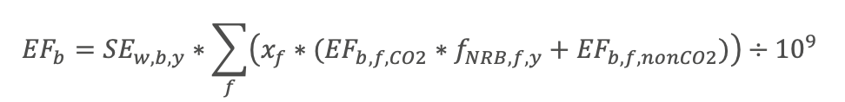

SEw,b,y =360.83/ ηwb = 3,404 kJ/L

ηwb=(10* Xwood +20* Xcharcoal)/100= 0.106

Xwood =94%

Xcharcoal =6%

EFb = 3,404 *∑ (96.03+10.89) / 109= 0.000364 tCO2e/L

EFb wood = 94%*(112*82.77%+9.46)= 96.03

EFb charcoal =6%*(165*82.77%+44.83)= 10.89

EFb wood CO2= 112

EFb charcoal CO2=165

EFb wood non,CO2= 9.46

EFb charcoal non,CO2= 44.83

fNRB,f,y= 82.77%



BEy = 0.000364* (1-3%-0)* 91,579,492 *1 = 30,973

Qy = min( Qm,y ,Qpop,y )

Qm,y = 581,641,400

Qpop,y = 47,596 * 5.5 * 347 = 90,836,699

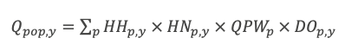

Project emissions calculations



PEff,p,y = 0



𝑃𝐸𝑒𝑐,𝑝,𝑦  = 3,968 * 0.0008*(1+20%) = 4 tCO2e/y

PEy= 0+4=4



ERy= 42,827 - 4 – 0 = 42,823 tCO2e/y

**Ex-ante calculations related to the outcomes of SDG 6**

HHsafe= HH* Mq,y

HHsafe = 8,824 * 1=8,824 number of households

HHsafe =6 *1= number of boarding schools

**Ex-ante calculations related to the outcomes of SDG 8**

EG= EGproject - EGbaseline

EG= 202-0 = 202 number of employee

B.6.4. Summary of ex ante estimates of each SDG outcome

SDG 13

|  |  |  |  |
| --- | --- | --- | --- |
| YEAR | BASELINE ESTIMATE | PROJECT ESTIMATE | NET BENEFIT |
| 28/10/2022-27/10/2023 | 21,932 | 4 | 21,932 tCO2e |
| 28/10/2023-27/10/2024 | 30,973 | 4 | 30,973 tCO2e |
| 28/10/2024-27/10/2025 | 30,973 | 4 | 30,973 tCO2e |
| 28/10/2025-27/10/2026 | 30,973 | 4 | 30,973 tCO2e |
| 28/10/2026-27/10/2027 | 30,973 | 4 | 30,973 tCO2e |
|  |  |  |  |
| Total 145,823 tCO2e |  |  |  |
| **Total number of crediting years** | 5 | | |
| **Annual average over the crediting period** | 29165 | tCO2e |  |
|  |  |  |  |

**SDG 6**

Ex-ante estimations of SDG 6 Outcomes

- 47,569 persons are having access to the safe and clean water provided by the project

Ex-ante estimations of SDG 8 Outcomes

* 202 number of jobs created (of which 129 female employee).

**B.7. Monitoring plan**

B.7.1. Data and parameters to be monitored

|  |  |
| --- | --- |
| Data / Parameter | Mq,y |
| Unit | Fraction |
| Description | Ongoing water quality indicated as the fraction of the samples that pass microbial quality standard requirements specified in relevant microbial quality standard for drinking water of the host country. |
| Source of data | Water quality testing over a minimum sample size of 30 to be collected at household level. |
| Value(s) applied | Estimated 100% of tests resulting conform to national standard for qater quality |
| Measurement methods and procedures | The water quality test applies the bacterial quality standard <1 cfu/100ml, and the sampling determines the proportion of pass and fail results. The sample size is following 90/10 precision rule and a minimum sample size of 30 must be selected. The water sample is taken at water outlet of the project water purifiers randomly from project database. |
| Monitoring frequency | Annual sampling, and the first round of testing shall be conducted at least after six months from the start date. |
| QA/QC procedures | Water quality testing will be performed by accredited laboratory: “Water Quality Division, Manyara Water Quality Lab”. |
| Purpose of data | Estimation of CO2e emission reductions |
| Additional comment | **-** |

|  |  |
| --- | --- |
| Data / Parameter | QPWp |
| Unit | Liters/person/day |
| Description | Volume of drinking water per person per day for premises type p |
| Source of data | Water Consumption Field Test |
| Value(s) applied | 5.5 |
| Measurement methods and procedures | For ex-ante estimation 5.5 L/person/day and 4 L/p/d in case of boarding schools.  The WCFT will conduct with end-users representative of the project scenario target population and currently using the project technology. |
| Monitoring frequency | Every two years |
| QA/QC procedures | - |
| Purpose of data | Estimation of CO2e emission reductions |
| Additional comment | **-** |

**SDG 13**

|  |  |
| --- | --- |
| Data / Parameter | Qm,y |
| Unit | Liters/year |
| Description | Monitored quantity of safe water provided by the CWS/CWT project in year y |
| Source of data | Flow meter measures water volume directly |
| Value(s) applied | Will be reported for each monitoring period. For ex ante  Estimation: 5.5 L/person/day |
| Measurement methods and procedures | Flow meter measures water volume directly  For ex-ante estimation 5.5 L/person/day and 4 L/p/d in case of boarding schools |
| Monitoring frequency | Continuously |
| QA/QC procedures | Follow manufacturer, sector, national or international standards or guidelines for calibration and maintenance of the measurement device. |
| Purpose of data | Estimation of CO2e emission reductions |
| Additional comment | Applies to CWT and CWS projects |

|  |  |
| --- | --- |
| Data / Parameter | Xcleanboil,y |
| Unit | Percentage |
| Description | Proportion of project end-users that boil safe (treated, or from safe supply) water after installation of project technology in year y |
| Source of data | Project survey |
| Value(s) applied | 0.1 |
| Measurement methods and procedures | A project Survey shall be carried out to determine the value using sampling plan as detailed in section B.7.2 |
| Monitoring frequency | Annually |
| QA/QC procedures | - |
| Purpose of data | Estimation of CO2e emission reductions |
| Additional comment | - |

|  |  |
| --- | --- |
| Data / Parameter | HNp,y |
| Unit | Number |
| Description | Number of individuals per premises type p in the project boundary in year y |
| Source of data | Baseline survey 2022 and annual monitoring survey |
| Value(s) applied | 5 |
| Measurement methods and procedures | Sampling for project survey should be carried out following the General requirements for sampling as per section 4.2 of the methodology.  For boarding schools, official data on the number of boarding students will be used. |
| Monitoring frequency | Annual |
| QA/QC procedures | The value applied shall be cross-checked against at least one other source on the list. For cross-check purposes, sources applied may be up to 5 years old. Further, cross-check with older sources may be used provided they provide conservative results.  Average households’ size: 6.86[8] |
| Purpose of data | Estimation of CO2e emission reductions |
| Additional comment | Baseline survey for ex-ante estimation. Value will be updated after the project survey accordingly |

|  |  |
| --- | --- |
| Data / Parameter | HHp,y |
| Unit | Number |
| Description | Number of premises type p served by the project in year y |
| Source of data | Survey of the premises (e.g. households, schools) within 1 km distance of project water source to check how often the premises used the project water source during the year. |
| Value(s) applied | 8,824 |
| Measurement methods and procedures | Complete end users census |
| Monitoring frequency | Annually |
| QA/QC procedures | NA |
| Purpose of data | Estimation of CO2e emission reductions |
| Additional comment |  |

|  |  |
| --- | --- |
| Data / Parameter | DOp,y |
| Unit | Days |
| Description | Days the project technology is operational for end-users in premises p in year y |
| Source of data | Demonstrate from log of operation and maintenance system. |
| Value(s) applied | 347 |
| Measurement methods and procedures | Local representative will keep continuously note from log of operation and maintenance system. For schools and other institutions, as applicable, the days must also be limited by the number of school days in the period, taking into account weekends and holidays. |
| Monitoring frequency | Annually |
| QA/QC procedures | Values higher than 347 days may only be applied when option 1 is used. 347 days is 95% of days, in line with pump-maintenance in the literature.  For schools and other institutions, as applicable, the days must also be limited by the number of school days in the period, taking into account weekends and holidays. |
| Purpose of data | Estimation of CO2e emission reductions |
| Additional comment | Applies to CWT, CWS projects and IWT (schools) |

|  |  |
| --- | --- |
| Data / Parameter | *Pp,f,y* |
| Unit | Mass or volume units (e.g. kg, Litres, standard m3) |
| Description | Quantity of fossil fuel *f* that is consumed in the project during year *y* |
| Source of data | Where back-up fossil-fuel engine(s) are used, any of the following methods will be used:  - direct measurements, - fuel invoice or purchase receipt  - manufacturer’s specification of the equipment and operating hours or volumes (e.g. fuel consumption per hour times utilization hours or fuel consumption per litre times the litres of water treated). |
| Value(s) applied | 0 |
| Measurement methods and procedures | Demonstrate from log of operation and maintenance system. |
| Monitoring frequency | Continually |
| QA/QC procedures | Follow manufacturer, sector, national or international standards or guidelines for calibration and maintenance of the measurement device. |
| Purpose of data | Estimation of CO2e emission reductions |
| Additional comment | The monitored fuel amount will be used to estimate the number of operating hours during the monitoring period.  The result will be compared to the total number of operating hours of the project pump for the same period.  If the use of the engine surpasses 10% of pump operating hours, then determine the number of days in which the backup technology was used to operate the pump for more than 10% of total operating hours during the day. The project is ineligible for crediting on the days when the use of back-up technology was more than the 10% threshold, and the number of ineligible days shall be subtracted from DOp,y.  Refer to Figure 6 Example of energy system (solar panels and backup). |

|  |  |
| --- | --- |
| Data / Parameter | *ECp,y* |
| Unit | KWh |
| Description | Quantity of electricity that is used by the project during year y |
| Source of data | Where back-up electricity are used, any of the following methods will be used:  - Direct measurement with electric meter  - Sample based using electricity loggers, or  - In the case of direct electricity use by water treatment  systems, may be estimated from the manufacturer’s  specification of the equipment and operating hours or  volumes (e.g. electricity consumption per hour times  utilization hours or electricity consumption per litre times  the litres of water treated). |
| Value(s) applied | 0 |
| Measurement methods and procedures | Demonstrate from log of operation and maintenance system. |
| Monitoring frequency | Continually |
| QA/QC procedures | Follow manufacturer, sector, national or international standards or guidelines for calibration and maintenance of the measurement device. |
| Purpose of data | Estimation of CO2e emission reductions |
| Additional comment | N/A |

|  |  |
| --- | --- |
| Data / Parameter | LEy |
| Unit | tCO2e per year |
| Description | Leakage emissions during year y |
| Source of data | Sources established by following Leakage emissions section |
| Value(s) applied | Ex-ante estimation: 0 |
| Measurement methods and procedures | Field survey |
| Monitoring frequency | Every two years |
| QA/QC procedures | Compliance with the general requirements for sampling and general requirements for data and information sources |
| Purpose of data | Estimation of CO2e emission reductions |
| Additional comment | Monitoring parameters required for calculating leakage emissions shall be included in the monitoring plan in the PDD as required to monitor and quantify the sources of leakage determined by following the Leakage emissions section. |

|  |  |
| --- | --- |
| Data / Parameter | Water hygiene education campaigns |
| Unit | NA |
| Description | Hygiene campaigns carried out among project safe water end-users.  The following guidelines apply for conducting these campaigns19   * Hygiene refers to access to sanitation amenities, equipment and infrastructure, as well as to the behaviour in respect to regular and correct use of such amenities. It also refers to behaviour that prevents infections from water-related diseases. * The project developer shall report the activities conducted each year in a detailed “Report of annual hygiene campaigns results” and summarize the results in the project monitoring reports. * Any major changes in the health status of the water users as a result of contaminated water (e.g. an outbreak of water related disease) must be reported and, if relevant, a strategy put in place to address it through the subsequent hygiene campaign. * The detailed method used to assess hygienic handling of clean water must be provided with the PDD and verified by the VVB. * The details of the method should be adjusted to suit the circumstances of each project and also to suit learning year on year.   The impacts of the hygiene campaign shall be assessed using the WHO/UNICEF Joint Monitoring Programme Core questions for drinking water and hygiene to determine the fraction of the households and institutions where Safe water and Hygiene practices are found to fulfill “safely managed” or “basic” requirements.  In-person or telephone or by messaging (e.g. text, app) based survey shall be conduct covering all the JMP core questions for drinking water and core questions for hygiene.  For sampling requirements, follow section 4.2 |General requirements for sampling, below.  The JMP core questions for households, schools and health care facilities are available at https://washdata.org/monitoring/methods/core-questions |
| Source of data | Report of annual hygiene campaigns results |
| Value(s) applied | Report of the annual hygiene campaigns |
| Measurement methods and procedures | - |
| Monitoring frequency | Annually |
| QA/QC procedures | The fraction of the households where Safe water and Hygiene practices are found to fulfil “safely managed” or “basic” requirements is expected to increase over time as a result of the hygiene campaigns. |
| Purpose of data | Estimation of CO2e emission reductions |
| Additional comment | Applies to all project technology types. |

B.7.2. Sampling plan

The sampling approach is to be used for following surveys as summarized below:

**Project Survey (PS) of end-user characteristics**

- The Project Survey has the same requirements as the Baseline Survey (described in Section B.4 of this PDD) regarding the representativeness and sample sizing i.e. at least 100 households need to be sampled when the target groups size is > 1000.

- When applicable the Project Survey and the Usage Survey will be implemented together using the same sample.

**Water Consumption Field Test (WCFT)**

- Two valid options are allowed for the statistical analysis of the WCFT. In all cases, the sample size must be greater than 20:

* 1. 90/10 rule. When the sample sizes are large enough to satisfy the “90/10 rule”, i.e. the endpoints of the 90% confidence interval lie within +/- 10% of the estimated mean, overall emission reductions can be calculated on the basis on the estimated average value for each of the respective variable mentioned above.
  2. 90% confidence rule. When the sample size is such that the “90/10 rule” is not complied with, the result used for the each of the respective variable mentioned above is not the mean (or average) test result, but a lower value, i.e. the lower bound of the one-sided 90% confidence interval (in order to reach a conservative estimate).

**Water quality testing**

- The sample for water quality testing will be made following the 90/10 precision rule indicated by the applied methodology. A minimum sample size of 30 must be selected.

**System Manteinance Reporting**

- A timeline of system manteinance operations led by local WASH committees will be provided at the time of Verification. Potential non-operative days won’t be considered within the creditable period.

**Usage Survey**

- In line with the applied, any sampling methods can be used, provided that the sample is selected randomly. If sampling approach other than simple random sampling is applied, ‘Guidelines for sampling and survey for CDM project activities and program of activities’ must be followed.

- When applicable the Usage Survey and the Project Survey will be implemented together using the same sample.

**Leakage Assessment**

- Leakage assessment regarding the potential leakage sources will be completed every other year together with the Usage Survey and therefore no separate sampling approach are used for the leakage assessment.

B.7.3. Other elements of monitoring plan

In line with the methodology, the monitoring activities will involve data collection during distribution, installation and construction as well as post-implementation usage information regarding the project safe water supply / treatment technologies.

Firstly, the project proponent must to keep records of the information collected in an electronic database for enabling the unique identification of the project water supply systems. This database will include the following information:

- Unique identification number of each Water Supply System

- Date of installation of each Water Supply System

- GPS location of each Water Supply System

- Model of the pump and filter used for each Water Supply System

- Total quantity of the constructed Water Supply Systems

- The total number of people obtaining their water from each Water Supply System

The total number of households using each water supply and treatment system will be determined through the lists supplied for example by the community group and or district water officer responsible for that water supply and treatment system. Using this method, the total number of people using each borehole can be determined and hence a figure for person days can be calculated. Moreover, this list will be used for confirming that the end-user households locate within 1 km from the water source.

Secondly, after the project implementation start, the project proponent must conduct the following studies for each project scenario:

A. Project Non-Renewable Biomass (NRB) Assessment – at least at renewal of crediting period

In accordance with the methodology, the NRB assessment will remain fixed for the entire crediting period, although the project proponent may choose to re-examine the assessment at any time following the guidelines of the applied methodology. In case of a renewal of the crediting period and as per Gold Standard rules, the NRB fraction must be reassessed as any other baseline parameters and updated in line with most recent data available.

B. Project Survey (PS) of end-user characteristics – completed annually

The safe water project survey has the same requirements as the baseline survey (described in Section B.4 of this PDD) but is conducted with end-users representative of the project scenario target population and currently using the safe water project technology.

In the guidance data collected, questions about end-user characteristics and baseline technology and fuels should be treated as specific to safe water supply and water treatment. These questions should be asked twice, first regarding to the baseline scenario water supply and water treatment, including boiling technologies, and second in regards to the project scenario clean water supply, including treatment and boiling technologies.

During the monitoring activities the Project Survey and the below described Usage Survey will be implemented together.

C. Baseline Water Boiling Test (BWBT) - completed at least once

The BWBT has been performed ex-ante. If the later monitoring surveys reveal that the same water boiling technologies are prevalent in the baseline and project scenarios, Wb,y and Wp,y are equal. The BWBT should be updated if monitoring surveys show that water boiling technologies change over time.

Under certain circumstances the baseline scenario may require updating, in which case new baseline water boiling test may be necessary.

In case a new baseline water boiling test (BWBT) is conducted to calculate the quantity of fuel required to purify by boiling one liter of water for 10 minutes using technologies and fuels representative of the baseline scenario (Wb,y).

D. Water Consumption Field Test (WCFT) - completed at least biennially

The project proponent will carry out the WCFT to determine the actual safe water consumption and boiling volumes (both of raw/unsafe water and safe water) for each project scenario. The WCFT is to be completed prior to first verification and then at least every two years after with randomly selected end-users representative of the project scenario target population and currently using the project technology following the WCFT Procedure designed for the project .

Three different volumetric variables are measured:

Qp Quantity of safe water in litres consumed in the project scenario p and supplied by project technology per person per day

Qp,rawboil,y Quantity of raw or unsafe water boiled in the project scenario p per person per day

Qp,cleanboil,y Quantity of safe (treated, or from safe supply) water boiled in the project scenario p per person per day

E. On-going Monitoring Studies: Usage rates, leakage, water quality

Water quality testing – completed every quarter

The quality of the treated water will be assessed to ensure that it is fit for human consumption. In line with the national standard the quality shall be 0 Colony Forming Unit (CFU) of E.Coli / 100 ml of safe water . The water quality must be tested every quarter, with the first test within 6 months of the stated project start date. In addition project participants shall ensure that water quality is tested at least once during season where there is a high chance of contamination, for example the rainy season.

The quarterly water quality testing is foreseen to be made in a laboratory or alternatively conducted via field tests like IDEXX presence/absence tests in 100 ml for E. Coli. However, at least ones every two years, an accredited laboratory will perform the water quality testing. It is the decision of the accredited laboratory whether they perform the test in the field using water quality field test kits or define an adequate procedure for transporting the water samples to their laboratory. The water quality testing with the accredited laboratory shall be carried out at a time when there is the most annual chance of contamination. If accredited laboratory results differ materially from non-accredited laboratory results, testing with the aberrant non-accredited laboratory must be discontinued. Lab where tests are conducted is the official water office of Dolo Ado Woreda (Ethiopian district) or, in alternative, any accredited laboratory available in the near distance. WHO Guidelines of water quality standards are followed for water testing.

Also, the monitoring of hygienic use of water at the end-user end may further complement the testing process.

Usage Survey – completed at least annually

The Usage Survey is completed annually, or more frequently, and all cases on time for any request of issuance. The usage survey provided a single usage parameter that is weighted based on drop off rates that are representative of age distribution for project technologies in the sales/distribution/construction record.

A usage parameter must be established to account for drop off rates as project technologies age are replaced. Prior to verification, a usage parameter is required that is weighted to be representative of the quantity of project technologies of each age being credited in a given project scenario. For example if only technologies in the first year of use (age0-1) are being credited, a usage parameter must be established through a usage survey for technologies age0-1. If an equal number of technologies in the first year of use (age0-1) and second year of use (age1-2) are credited, a usage parameter is required that is weighted to be equally representative of drop off rates for technologies age0-1 and age1-2. To ensure conservativeness, the usage survey with technologies in the first year of use (age0-1) must have technologies that have been in use on average longer than 0.5 years. For technologies in the second year of use (age1-2), the usage survey must be conducted with technologies that have been in use on average at least 1.5 years, and so on.

Leakage Assessment – completed every other year

As the leakage risks related to the safe water supply and treatment technologies can be deemed very low, the leakage can be ignored, and leakage is expected to be 0. However, to confirm that leakage can be deemed very low, the below described leakage assessment regarding the potential leakage sources shall be completed every other year, starting on time for the first verification in line with the section 2.6 (“Leakage”) of the applied methodology.

a) The displaced baseline technologies are reused outside the project boundary in place of lower emitting technology or in a manner suggesting more usage than would have occurred in the absence of the project.

Not applicable and therefore not counted. In this project the baseline technologies are referring to the methodologies used for water boiling which are traditional charcoal stoves and three stone fires. As these baseline methodologies will be continued to be used by the families for cooking activities (even though the project will replace the need for boiling the water for purification purposes), it’s not foreseen that the project would lead to the displacement of the baseline technologies outside the project boundary.

b) Non-project users who previously used lower emitting energy sources use the non-renewable biomass or fossil fuels saved under the project activity.

Not applicable and therefore not counted. The energy sources used in the baseline for water boiling are charcoal and firewood. It is very unlikely that users who previously (in the baseline) used for example non-GHG emitting methods like use of liquid chlorine for water purification would switch to boiling drinking water because another ‘zero emission’ technology is promoted by the project.

c) The project significantly impacts the NRB fraction within an area where other CDM or VER project activities account for NRB fraction in their baseline scenario.

Not applicable and therefore not counted. It’s not expected that it will have significant influence on the national NRB fraction. Also, relevant registry have been consulted and no other activities accounting for NRB fraction has been found.

d) The project population compensates for loss of the space heating effect of inefficient technology by adopting some other form of heating or by retaining some use of inefficient technology.

Not applicable and therefore not counted. It is unlikely that households would had used the boiling of drinking water for space heating. In addition, end-users retain use of the baseline technologies for cooking and the difference in heat effects from no longer boiling water can be considered minimal. Any retaining use of inefficient technology for water boiling will, anyhow, be covered in the results of the water consumption field test (WCFT).

e) By virtue of promotion and marketing of new technology with high efficiency, the project stimulates substitution within households who commonly used a technology with relatively lower emissions, in cases where such a trend is not eligible as an evolving baseline. Not applicable and therefore not counted. The technologies used in the baseline for water boiling are three stone fires and traditional charcoal stoves with either non-renewable biomass or fossil fuels and/or the end-users are lacking access to safe water. It is very unlikely that users who previously (in the baseline) used for example non-GHG emitting methods like use of liquid chlorine for water purification would switch to boiling drinking water because another ‘zero emission’ technology is promoted by the project. In case residual usage of fossil fuels would take place in the project scenario, relative households will not be accounted for Emission Reductions.

F. Hygiene Survey – completed annually

Project Proponent will carry out each year hygiene campaigns (as described below) and report the activities conducted as well as the number of the participants in the organized campaigns and the number of the trained personnel in the annual monitoring report. Any major changes on the health status of the water users as a result of contaminated water (e.g. an outbreak of water related disease) will be reported and, if relevant, a strategy put in place to address it through the hygiene campaign. Hygiene refers here to access to sanitation amenities, equipment and infrastructure, as well as to the behavior in respect to regular and correct use of such amenities. It also refers to behavior that prevents infections from water-related diseases.

Below are described the designed activities for promoting hygiene. These activities will be adjusted when needed to suit learning year on year or if proven unsuccessful.

The success of education on hygiene issue will also be monitored through the WCFT which will study the ratio of end-user that are still boiling their drinking water in the project scenario and through the usage/monitoring survey to check on the use of clean/safe containers and devices for transport and storage of water used for drinking, cooking, food preparation and basic personal hygiene. In case needed the education on the hygiene will be adjusted if proven unsuccessful.

Description of hygiene campaigns:

All the hygiene campaigns are foreseen to be based on “Water, Sanitation, and Hygiene Improvement, Training Package for the Prevention of Diarrheal Disease, Guide for Training Outreach Workers, USAID Hygiene Improvement Project, 2009” which is referred to in the applied methodology.

1) Annual hygiene campaigns

Each year at least one campaign on water, sanitation and health related issues will be realized. The place and organization method of the event may vary from year to year and will be selected also to suit learning year on year. Examples of the methods which may be used for the campaigns are events, radio campaigns or sessions on hygiene included in some other event or training organized with the local stakeholders. Information is handed out to the end-users also via leaflets when applicable.

2) Information sharing done during the usage/monitoring survey and other monitoring activities

All the agents conducting the usage survey or other project monitoring activities will be trained on communicating hygiene information. In fact, the visiting of project households during the usage/monitoring survey (conducted annually for at least 100 project households), or during the other project monitoring activities when applicable, each interviewed family will be sensitized on the benefits of the hygiene in general and on the ways of the hygiene handling of clean water to encourage behavior change and prevent relapse after campaigns. Furthermore, the usage survey itself will include questions enabling to monitor the hygiene related issues:

- Usage/monitoring survey will study qualitatively the occurrence of diarrhea and other water borne diseases in the project scenario in comparison with the baseline scenario. The participants of the survey are asked to evaluate if they experience less, more or the same amount of diarrhea and other water borne diseases as before the project.

- Usage/monitoring survey will check qualitatively on the hygiene handling like use of clean/safe containers and devices for transport and storage of water used for drinking, cooking, food preparation and basic personal hygiene.

## SECTION C. DURATION AND CREDITING PERIOD

C.1 Duration of project

C.1.1 Start date of VPA

13/07/2021

C.1.2. Expected operational lifetime of VPA

15 years

C.2 Crediting period of project

C.2.1 Start date of crediting period

28/10/2022

C.2.2 Total length of crediting period

1. years, renewable.

## SECTION D. SUMMARY OF SAFEGUARDING PRINCIPLES AND GENDER SENSITIVE ASSESSMENT

**D.1. Safeguarding Principles that will be monitored**

A completed Safeguarding Principles Assessment is in Appendix 1, ongoing monitoring is summarised below.

|  |  |
| --- | --- |
| PRINCIPLES | MITIGATION MEASURES ADDED TO THE  MONITORING PLAN |
|  | N/A |
| **Principle 1. Human Rights** | N/A |
| **Principle 2. Gender Equality** | N/A |
| **Principle 3. Community Health,  Safety and Working Conditions** | N/A |
| **Principle 4.1 Sites of Cultural  and Historical Heritage** | N/A |
| **Principle 4.2 Forced Eviction  and Displacement** | N/A |
| **Principle 4.3 Land Tenure and  Other Rights** | N/A |
| **Principle 5. Corruption** | N/A |
| **Principle 6.1 Labour Rights** | N/A |
| **Principle 6.2 Negative Economic  Consequences** | N/A |
| **Principle 7.1 Emissions** | N/A |
| **Principle 7.2 Energy Supply** | N/A |
| **Principle 8.1 Impact on Natural  Water Patterns/Flows** | N/A |
| **Principle 8.2 Erosion and/or  Water Body Instability** | N/A |
| **Principle 9.1 Landscape  Modification and Soil** | N/A |
| **Principle 9.2 Vulnerability to  Natural Disaster** | N/A |
| **Principle 9.3 Genetic Resources** | N/A |
| **Principle 9.4 Release of pollutants** | N/A |
| **Principle 9.5 Hazardous and  Non-hazardous Waste** | N/A |
| **Principle 9.6 Pesticides & Fertilisers** | N/A |
| **Principle 9.7 Harvesting of Forests** | N/A |
| **Principle 9.8 Food** | N/A |
| **Principle 9.9 Animal husbandry** | N/A |
| **Principle 9.10 High Conservation  Value Area sand Critical Habitats** | N/A |
| **Principle 9.11 Endangered Species** | N/A |

**D.2. Assessment that project complies with GS4GG Gender Sensitive requirements**

|  |  |
| --- | --- |
| Question 1 - Explain how the project reflects the key issues and requirements of Gender Sensitive design and implementation as outlined in the Gender Policy? | The project reflects the key issues and requirements of gender sensitive design and implementation: The project activities provide access to clean and safe water for local communities. The access to water is free and located in central places and thus will not put at risk the access of women or any other marginalized groups. The access to clean and safe water will contribute to improve health of the local population and will reduce the workload related to the water purification activities. The reduction on the workload benefits especially women and girls who are mainly responsible on fuel collection and water purification activities. The implemented activities related to the stakeholder consultation as well as the future implementation of the project activities takes into the account gender roles and the abilities of women and men to participate in the decision/designs of the project activities. For example, the stakeholder consultation made in the project design phase was designed in a way which enabled both women and men participating in the consultation meeting (Please refer to the separate Stakeholder Consultation Report uploaded to SC application). Moreover, for example, the future annual hygiene campaigns will be planned and organized in the way to avoid any discrimination of women or other marginalized groups. In fact, the women’s participation will be essential for guaranteeing the success of the project. |
| Question 2 - Explain how the project aligns with existing country policies, strategies and best practices | The Project is in line with Tanzania’s constitution. Tanzania has ratified the principle of equality into its respective constitution (Article 9), which shall guarantee equal gender rights.  Article 9 (g) mentions ‘that the Government all its agencies accord equal opportunities to all citiyens, men and women alike without regard to their color, tribe, region, or station in llife It will be ensured that the project is committed to equal gender rights and women empowerment following  Tanzania’s constitution. |
| Question 3 - Is an Expert required for the Gender Safeguarding Principles & Requirements? | N/A |
| Question 4 - Is an Expert required to assist with Gender issues at the Stakeholder Consultation? | N/A |

## SECTION E. SUMMARY OF LOCAL STAKEHOLDER CONSULTATION

The below is a summary of the 2 step GS4GG Consultation for monitoring purposes. Pleaserefer to the separate Stakeholder Consultation Report for a complete report on the initial consultation and stakeholder feedback round.

E.1. Summary of stakeholder mitigation measures

Two stakeholder consultation meetings were conducted in May 2022 (11- 12/05/2022) attended by a total of 231 people. All relevant stakeholders (including local communities, marginalized groups, local policy makers, national government officials, local NGOs, gold standard representatives, relevant international NGOs) were invited for the stakeholder consultation meetings. Invitations, where possible, have been distributed by letter or otherwise by email, in both English and local language. All invitees were encouraged to spread the invitation to anyone who might be interested in the meeting. To encourage participation, a reimbursement was provided for the transport costs that the local stakeholders might encounter.

During the meeting it was illustrated that the project is addressed to supply safe drinking water for domestic use and consequently to improve hygiene, social, economic and environmental issues related to the water consume. Moreover, verifiable Carbon Dioxide (CO2) emission reductions are achieved through the reduced wood/charcoal combustion and the need for water purification through boiling is reduced. The project will also raise awareness among population regarding hygiene-related themes and contribute to sustainable development.

Besides reducing greenhouse gas emission and contributing to climate change mitigation in line with the UN’s Sustainable Development Goal no 13 (“Climate Action”), the project activities are foreseen to contribute to sustainable development in the following ways:

- Increased number of households with access to improved sources of safe water (SDG 6)

- Creation of new employment and income opportunities for the local community (SDG 8)

Five relevant comments have been raised during the meetings seeking specific clarification on different aspect of the project and several evaluation forms have been filled by the stakeholders. No alterations to the project design have been identified based on the comments received.

The Stakeholder Feedback Round was organized between 19/12/2024 – 19/01/2024.

During this month period the hard copy of the PDD draft including the report on

the Stakeholder Consultation was disposed in the central place of the project area agreed during the stakeholder meetings and made publicly available also online in the Sustaincert Application. No comments have been received during the stakeholder feedback round.

**E.2. Final continuous input / grievance mechanism**

|  |  |
| --- | --- |
| METHOD | INCLUDE ALL DETAILS OF CHOSEN METHOD (S) SO THAT THEY MAY BE UNDERSTOOD AND, WHERE RELEVANT, USED BY READERS. |
| Continuous Input / Grievance Expression Process Book (mandatory) | Books for Grievance Expression and Continuous Input about the project have been put in strategic locations for each village. (RUWASA offices). |
| GS Contact (mandatory) | [help@goldstandard.org](mailto:help@goldstandard.org) |
| Other | +255 (0) 787 450 035 (Oikos office)  contact@oikosea.org |

## SECTION F. Eligibility and inclusion criteria for VPAs inclusion

The below table shall be completed for all VPAs.

The CME shall provide clear description on how eligibility criteria set at real case VPAs are complied with for each real case and regular VPAs submitted for inclusion.

The CME shall not change the eligibility criteria and required condition set at real case VPAs. At the time of inclusion of regular VPAs, the CME shall only describe how the regular VPAs comply with the eligibility criterion.

|  |  |  |  |
| --- | --- | --- | --- |
| NO. | ELIGIBILITY CRITERION | DESCRIPTION/  REQUIRED CONDITION | DESCRIPTION OF THE VPA IN RELATION TO THE CRITERIA, MEANS OF VERIFICATION/SUPPORTING EVIDENCE  FOR INCLUSION |
| 1 | Types of  Project | Eligible projects shall  include physical action/implementation  on the ground. Preidentified eligible project types are identified in the Eligibility Principles and Requirements section. | The project provides access to clean water for household being thus Community Service WASH activity. More precisely, the project includes the excavation and rehabilitation of boreholes.  Therefore, the project activity falls under section 3.1.1  (b) “End-Use Energy Efficiency Improvement: Project activities that reduce energy requirements as compared to baseline scenario without affecting the level and quality of services or products, where the end user of the products and services are clearly identified and when the physical intervention is required at the user end.” and (d) “Water, sanitation and hygiene (WASH): WASH activities contributing to climate change mitigation and/or adaptation benefits” of GS4GG Community Services Activity Requirements (Version 1.2).  As per section 4.1.3 of GS4GG Principles & Requirements (Version 1.2), “A Project type is automatically eligible for Gold Standard Certification if there are Gold Standard approved Activity Requirements and/or Impact Quantification Methodologies associated with it or it’s referenced in the Gold Standard Product Requirements”. The project type is automatically eligible for Gold Standard Certification. |
| 2 | Location of Project | Projects may be located in any part of the world. | The project location is the United Republic of Tanzania. (refer to section A.2 of the PDD for detailed project area and boundary) and there are no mandatory operational schemes to reduce GHG emissions in any form (e.g., cap & trade, carbon tax etc.) in Tanzania, which based on section 3.1.1 of GS4GG GHG Emissions Reduction & Sequestration Product Requirements (Version 2.0) is an eligible host country. |
| 3 | Project Area, Project Boundary and Scale | The Project Area and Project Boundary shall be defined. Projects may be developed  at any scale although certain rules, requirements and limitations  may apply under specific Activity Requirements, Impact  Quantification Methodologies and Products Requirements.  In order to avoid double counting the Project shall not be included  in any other voluntary or compliance standards programme unless  approved by Gold Standard (for example through dual  certification). Also, if the Project Area overlaps with that of  another Gold Standard or other voluntary or compliance standard  programme of a similar nature, the project shall demonstrate that  there is no double counting of impacts at design and performance  certification (for example use of similar technology or practices  through which the potential arises for double counting or  misestimation of impacts amongst projects). | The project location is the United Republic of Tanzania. (refer to section A.2 of the PDD for detailed project area and boundary).  The project boundary is defined based on  Methodology for Emission Reductions from Safe Drinking Water Supply (Version 1.0) and is limited to the United Republic of Tanzania (refer to section B.3 of the PDD). The project takes place inside the geographical boundaries of Maryara Region, Tanzania.  This project is not included by any other carbon standard neither voluntary or compliant.  The avoiding of the double counting is confirmed in two ways:  - the Project Area does not overlap with other Gold Standard or other voluntary or compliance standard programme of a similar nature  - Each project water system will be identified with unique gps coordinates of its location which enables the unique identification of the borehole to be part of this project. |
| 4 | Host Country Requirements: | Projects shall be in compliance  with applicable Host Country’s legal, environmental, ecological  and social regulations. | This project is in compliance with Tanzania’s legal, environmental, and social regulations. The project is actively contributing to the Host Country by reducing the GHG emissions, fuel consumption as well as economic and time savings to thousands of poor households. |
| 5 | Contact Details: | As part of the Project Documentation the Project Developer shall provide (i) name and (ii) contact details of all Project Participants; AND in case of an organisation (iii) the  legal registration details and (iv) documentation by the governing  jurisdiction that proves that the entity is in good standing (defined as being a legal or other appropriate entity registered in or allowed to operate within the required jurisdiction and with no  evidence of insolvency or legal/criminal notices placed against it or any of its Directors). Gold Standard retains the right (at its own discretion) to refuse use of the Standard where reputational concerns are highlighted. | All the project participant information have been provided in Appendix 2. |
| 6 | Legal Ownership: | Full and uncontested legal ownership of any Products that are generated under Gold Standard Certification,  (for example carbon credits) shall be demonstrated. Where such  ownership is transferred from project beneficiaries this must be  demonstrated transparently and with full, prior and informed  consent (FPIC). Note that for certain Project types there is a requirement for full and uncontested legal land title/tenure to be demonstrated. These are contained within specific Activity or Product Requirements. All projects shall immediately report to Gold Standard any land title/tenure disputes arising. | The transfer of credit ownership from end-users and technology providers to the project developer is proved with written assertions signed by relevant representative.  Moreover, the credit ownership was also discussed during the stakeholder meeting and mentioned in the Project Summary provided to stakeholders. |
| 7 | Other Rights: | As well as legal title and ownership, the Project Developer shall also demonstrate where required uncontested legal rights and/or permissions concerning changes in use of other resources required to service the Project (for example, access rights, water rights etc.). Any known disputes or contested rights must be declared immediately to Gold Standard by the Project Developer and resolved prior to further project implementation in  affected areas | There are no disputes or contested rights that have been identified in relation to rights relevant to the project activity. |
| 8 | Official Development Assistance (ODA) Declaration: | All Project Developers applying for project activities located in a  country named by the OECD Development Assistance Committee’s ODA recipient list and seeking Gold Standard Certification for carbon credits shall declare the Official Development Assistance (ODA) support. The Project Developer shall follow the GHG Emissions Reduction & Sequestration Product Requirements and submit the declaration at the time of Design Certification. | It is confirmed that no Official Development Assistance (ODA) has been requested and none will be applied for the project activity. |
|  |  |  |  |

### Appendix 1 - Safeguarding Principles Assessment

Complete the Assessment below and copy all Mitigation Measures for each Principle into SECTION D above. Please refer to the instructions in the [Guide to Completing](https://globalgoals.goldstandard.org/t-prereview-vpa-design-document/) this Form below.

|  |  |  |
| --- | --- | --- |
| **SOCIAL SAFEGUARDING PRINCIPLES** | | |
| Reference requirement | Question | Response |
| **P.1 |Human Rights** | | |
| P.1.1.1 | | Does the project developer, its representatives and the Project disrespect internationally proclaimed human rights? | ☐ YES  ☒ NO |
| P.1.1.1 | | Is the project involved or complicit in violence or human rights abuses of any kind as defined in the Universal Declaration of Human Rights? | ☐ YES  ☒ NO |
| P.1.1.2 | | Have local communities or individuals raised human rights concerns regarding the project (e.g., during the stakeholder engagement process, grievance processes, public statements)? | ☐ YES  ☒ NO |
| P.1.1.3 | | Is there a risk that rights-holders (e.g., Project-affected stakeholders) do not have the capacity to claim their rights? | ☐ YES  ☒ NO |
| P.1.1.3 | | Does this project undermine national or regional measures for the realisation of the right to development? | ☐ YES  ☒ NO |
| If the answer to any of the questions above is "yes," please explain the reason and how the project will ensure compliance with applicable requirements. | | |
| *Please add text here…* | | |
| Would the project potentially involve or lead to: | | |
| P.1.1.1 | | adverse impacts on enjoyment of the human rights (civil, political, economic, social or cultural) of the affected population and particularly of marginalised groups? | ☐ YES  ☐ POTENTIALLY  ☒ NO |
| P.1.1.2 | | inequitable or discriminatory impacts on affected populations, particularly people living in poverty or marginalised or excluded individuals or groups, including persons with disabilities? | ☐ YES  ☐ POTENTIALLY  ☒ NO |
| P.1.1.3 | | restrictions in availability, quality of and/or access to resources or basic services, in particular to marginalised individuals or groups, including persons with disabilities? | ☐ YES  ☐ POTENTIALLY  ☒ NO |
| P.1.1.3 | | exacerbation of conflicts among and/or the risk of violence to project-affected communities and individuals? | ☐ YES  ☐ POTENTIALLY  ☒ NO |
| Briefly describe below how the project incorporates a human rights-based approach.  For example, by describing how the project design:   * is informed by human rights analysis, including from UN human rights mechanisms (human rights treaty bodies, universal periodic review, special procedures) * includes measures to assist the government to realise (respect, protect and fulfil) human rights under international law and to implement human rights-related standards in national law (whichever is higher) * enhances the availability, accessibility and quality of benefits and services for potentially marginalised individuals and groups, and to increase their inclusion in decision-making processes that may impact them (consistent with the non-discrimination and equality human rights principle) * provides reasonable accommodations to strengthen inclusivity and accessibility of project benefits and services to persons with disabilities. | | |
| *Please add text here….* | | |
| **P.2 |Gender Equality and Women’s Empowerment** | | |
| P.2.1.1 | | Have women’s groups/leaders raised gender equality concerns regarding the project, (e.g., during the stakeholder engagement process, grievance processes, public statements)? | ☐ YES  ☒ NO |
| P.2.1.2 | | Does the project undermine the principles of non-discrimination, equal treatment, and equal pay for equal work? | ☐ YES  ☒ NO |
| P.2.1.2 | | Does the project prevent men and women from having equal opportunities to participate in identified tasks and activities, whether through paid work, volunteer work, or community contributions, as appropriate? | ☐ YES  ☒ NO |
| P.2.1.2 | | Does the project limit the participation of women or men based on pregnancy, maternity/paternity leave, or marital status? | ☐ YES  ☒ NO |
| P.2.1.2 | | Is information about project objectives being communicated in a way that is inappropriate for the local context and not tailored to the methods of understanding of both women and men, which could hinder their participation? | ☐ YES  ☒ NO |
| P.2.1.3 | | Has the project assessed gender risks without referencing the country's gender strategy or equivalent national commitment? | ☐ YES  ☒ NO |
| P.2.1.4 | | Has expert stakeholder(s) been involved, and has their input been requested for the project design on gender equality and women's empowerment? | ☐ YES  ☒ NO |
| If the answer to any of the questions above is "yes," please explain the reason and how the project will ensure compliance with applicable requirements. | | |
| *Please add text here….* | | |
| Would the project potentially involve or lead to: | |  |
| P.2.1.1 | | adverse impacts on gender equality and/or the situation of women and girls? | ☐ YES  ☐ POTENTIALLY  ☒ NO |
| P.2.1.1 | | exacerbation of risks of gender-based violence? For example, through the influx of workers to a community, changes in community and household power dynamics, increased exposure to unsafe public places and/or transport, etc. | ☐ YES  ☐ POTENTIALLY  ☒ NO |
| P.2.1.2 | | reproducing discriminations against women based on gender, especially regarding participation in design and implementation or access to opportunities and benefits? | ☐ YES  ☐ POTENTIALLY  ☒ NO |
| P.2.1.2 | | limitations on women’s ability to use, develop and protect natural resources, taking into account different roles and positions of women and men in accessing environmental goods and services?  For example, activities that could lead to natural resources degradation or depletion in communities who depend on these resources for their livelihoods and well-being. | ☐ YES  ☐ POTENTIALLY  ☒ NO |
| Briefly describe below how the project is addressing any identified risk to gender equality and women’s empowerment. | | |
| *Please add text here….* | | |
| **P.3 |Community Health AND Safety** | | |
| P.3.1.1 | | Does the project involve potential risks to the health and safety of affected communities during its life cycle? | ☐ YES  ☒ NO |
| P.3.1.2 | | Does the project involve any potential risks to the workers' safety and health? | ☐ YES  ☒ NO |
| If the answer to any of the questions above is "yes," please explain the reason and how the project will ensure compliance with applicable requirements. | | |
| *Please add text here….* | | |
| Would the project potentially involve or lead to: | | |
| P.3.1.1 | | construction and/or infrastructure development (e.g., roads, buildings, dams)? | ☐ YES  ☒ NO |
| P.3.1.2 | | air pollution, noise, vibration, traffic, injuries, physical hazards, poor surface water quality due to runoff, erosion, sanitation? | ☐ YES  ☐ POTENTIALLY  ☒ NO |
| P.3.1.2 | | harm or losses due to failure of structural elements of the project (e.g., collapse of buildings or infrastructure)? | ☐ YES  ☐ POTENTIALLY  ☒ NO |
| P.3.1.2 | | risks of water-borne or other vector-borne diseases (e.g., temporary breeding habitats), communicable and noncommunicable diseases, nutritional disorders, mental health? | ☐ YES  ☐ POTENTIALLY  ☒ NO |
| P.3.1.2 | | transport, storage, and use and/or disposal of hazardous or dangerous materials (e.g., explosives, fuel and other chemicals during construction and operation)? | ☐ YES  ☐ POTENTIALLY  ☒ NO |
| P.3.1.2 | | adverse impacts on ecosystems and ecosystem services relevant to communities’ health (e.g., food, surface water purification, natural buffers from flooding)? | ☐ YES  ☐ POTENTIALLY  ☒ NO |
| Briefly describe below how the project is addressing any identified risk related to community health and safety. | | |
| *Please add text here….* | | |
| **P.4 |Cultural Heritage, Indigenous People, Displacement and Resettlement** | | |
| *P.4.1 |Sites of Cultural and Historical Heritage* | | |
| P.4.1.1 | | Does the project involve altering, damaging, or removing sites, objects, or structures of significant cultural heritage? | ☐ YES  ☒ NO |
| If the answer to question above is "yes," please explain the reason and how the project will ensure compliance with applicable requirements. | | |
| *Please add text here….* | | |
| Would the project potentially involve or lead to: | | |
| P.4.1.1 | | activities adjacent to or within a cultural heritage site? | ☐ YES  ☐ POTENTIALLY  ☒ NO |
| P.4.1.1 | | significant excavations, demolitions, movement of earth, flooding or other environmental changes? | ☐ YES  ☐ POTENTIALLY  ☒ NO |
| P.4.1.1 | | alterations to landscapes and natural features with cultural significance? | ☐ YES  ☐ POTENTIALLY  ☒ NO |
| P.4.1.1 | | adverse impacts to sites, structures, or objects with historical, cultural, artistic, traditional or religious values or intangible forms of culture (e.g., knowledge, innovations, practices)? (Note: projects intended to protect and conserve Cultural Heritage may also have inadvertent adverse impacts) | ☐ YES  ☐ POTENTIALLY  ☒ NO |
| P.4.1.2 | | utilisation of tangible and/or intangible forms (e.g., practices, traditional knowledge) of Cultural Heritage  for commercial or other purposes? | ☐ YES  ☐ POTENTIALLY  ☒ NO |
| P.4.1.2 | | If answer to question above is “YES” or “POTENTIALLY” - are the communities made aware of their right under the law, scope and nature of proposed development and its potential consequences? | ☐ YES  ☒ NO  ☐ NA |
| P.4.1.3 | | If answer to question above is “YES” - does the project provide equitable sharing of benefits from commercialisation of such knowledge, innovation, or practice, consistent with their customs and traditions? | ☐ YES  ☒ NO  ☐ NA |
| P.4.1.4 | | If answer to question above is “YES” - are opinions and recommendations of an Expert Stakeholder(s) not sought and demonstrated as being included in the project design? | ☐ YES  ☒ NO  ☐ NA |
| P.4.1.4 | | If answer to question above is “YES”, has project design been changed, modified, updated considering opinions and recommendations of an Expert Stakeholder? | ☐ YES  ☒ NO  ☐ NA |
| If the answer is "yes" or "potentially" to any of the above questions, please provide a brief description of the project situation below. Also, provide justification and/or evidence as necessary to demonstrate compliance with applicable requirements. | | |
| *Please add text here….* | | |
| P.4.2 |*Forced Eviction and Displacement* | | |
| P.4.2.1 | | Does the project involve any risks related to involuntary relocation of people? | ☐ YES  ☒ NO |
| If the answer to question above is "yes," please explain the reason and how the project will ensure compliance with applicable requirements. | | |
| *Please add text here….* | | |
| Would the project potentially involve or lead to: | | |
| P.4.2.1 | | risk of forced evictions or involuntary relocation of people? | ☐ YES  ☐ POTENTIALLY  ☒ NO |
| P.4.2.2 | | temporary or permanent and full or partial physical displacement (including people without legally recognisable claims to land)? | ☐ YES  ☐ POTENTIALLY  ☒ NO |
| P.4.2.2 | | economic displacement (e.g., loss of assets or access to resources due to land acquisition or access restrictions – even in the absence of physical relocation)? | ☐ YES  ☐ POTENTIALLY  ☒ NO |
| P.4.2.2 | | If answer to question above is “YES” or “POTENTIALLY”,   * has the project developed Resettlement Action Plan or Livelihood Action Plan in consultation and agreement with affected individual, group or community? * has the project integrated Resettlement Action Plan or Livelihood Action Plan into the Project design? | ☐ YES  ☒ NO  ☐ NA |
| P.4.2.3 | | If answer to question above is “YES” - are opinions and recommendations of an Expert Stakeholder(s) not sought and demonstrated as being included in the project design? | ☐ YES  ☒ NO  ☐ NA |
| P.4.2.3 | | If answer to question above is “YES”, have project design been changed, modified, updated considering opinions and recommendations of an Expert Stakeholder? | ☐ YES  ☒ NO  ☐ NA |
| If the answer is "yes" or "potentially" to any of the above questions, please provide a brief description of the project situation below. Also, provide justification and/or evidence as necessary to demonstrate compliance with applicable requirements. | | |
| *Please add text here….* | | |
| P.4.3 |Land tenure and other rights | | |
| P.4.3.1 | | Does the project involve any risks related to identifying and managing legitimate tenure rights that may be affected by the project? | ☐ YES  ☒ NO |
| If the answer to question above is "yes," please explain the reason and how the project will ensure compliance with applicable requirements. | | |
| *Please add text here….* | | |
| Would the project potentially involve or lead to: | | |
| P.4.3.1 | | impacts on or changes to land tenure arrangements and/or community-based property rights/customary rights to land, territories and/or resources? | ☐ YES  ☐ POTENTIALLY  ☒ NO |
| P.4.3.1 | | uncertainties with regards to land tenure, access rights, usage rights or land ownership?  Examples include, but are not limited to water access rights, community-based property rights and customary rights. | ☐ YES  ☐ POTENTIALLY  ☒ NO |
| P.4.3.2 | | Changes in legal arrangements, if yes, are the changes done in line with relevant laws and regulations? | ☐ YES  ☒ NO  ☐ NA |
| P.4.3.2 | | Changes in legal arrangements, if yes, are these changes agree with free, prior and informed consent of the involved stakeholders? | ☐ YES  ☒ NO  ☐ NA |
| P.4.3.3 | | Does some other entity (other than the project developer) hold uncontested land title for the entire Project Boundary? | ☐ YES  ☒ NO  ☐ NA |
| P.4.3.4 | | Are opinions and recommendations of an Expert Stakeholder(s) not sought and demonstrated as being included in the project design? | ☐ YES  ☒ NO  ☐ NA |
| P.4.3.4 | | If answer to question above is “YES”, have project design been changed, modified, updated considering opinions and recommendations of an Expert Stakeholder? | ☐ YES  ☒ NO  ☐ NA |
| P.4.3.5 | | Have project developer in consultation with stakeholders established a functioning mechanism to receive, process, resolve, communicate and record grievances? | ☐ YES  ☒ NO  ☐ NA |
| If the answer is "yes" or "potentially" to any of the above questions, please provide a brief description of the project situation below. Also, provide justification and/or evidence as necessary to demonstrate compliance with applicable requirements. | | |
| *Please add text here….* | | |
| P.4.4 |Indigenous peoples | | |
| P.4.4.1 | | Does the project involve Indigenous People within the Project area of influence who may be affected directly or indirectly by the Project? | ☐ YES  ☒ NO |
| If the answer to question above is "yes," please explain project situation and how the project will ensure compliance with applicable requirements. | | |
| *Please add text here….* | | |
| Would the project potentially involve or lead to: | | |
| P.4.4.1 | | affect areas where indigenous peoples are present (including project area of influence) | ☐ YES  ☐ POTENTIALLY  ☒ NO |
| P.4.4.1 | | affect areas, land and territory claimed by indigenous peoples? | ☐ YES  ☐ POTENTIALLY  ☒ NO |
| P.4.4.1 | | impacts (positive or negative) to the human rights, lands, natural resources, territories, and traditional livelihoods of indigenous peoples? | ☐ YES  ☐ POTENTIALLY  ☒ NO |
| P.4.4.7 | | If answer to above questions is ’’YES’’ or “POTENTIALLY”,   * Is it determined that the proposed project may affect the rights, lands, resources, or territories of indigenous people? * Has an "Indigenous People Plan" (IPP) or "Indigenous People Plan Framework" been elaborated and included in the project documentation? * Was the plan developed in accordance with the effective and meaningful participation of indigenous peoples and in accordance with UNDP Guidelines? | ☐ YES  ☒ NO  ☐ NA |
| P.4.4.3 | | risk of forcibly removing indigenous people from their lands and territories? | ☐ YES  ☐ POTENTIALLY  ☒ NO |
| P.4.4.4 | | utilisation and/or commercial development of natural resources on lands and territories claimed by indigenous peoples?  Consider, and where appropriate ensure, consistency with the answers under Principle 4.1 above | ☐ YES  ☐ POTENTIALLY  ☒ NO |
| P.4.4.5 |  P.4.4.6 | | If answer to question above is “YES” or “POTENTIALLY”   * Did the project obtain free, prior and informed consent from indigenous people before taking their cultural, intellectual, religious, and/or spiritual property? * Does the project ensure that the indigenous people receive an equitable sharing of benefits resulting from the use of their traditional knowledge and practices? ? * Does the project ensure that the sharing of benefits resulting from the use of indigenous peoples' traditional knowledge and practices is culturally appropriate and inclusive? * Does the project ensure that the provision of equitable sharing of benefits does not impede land rights or equal access to basic services including health services, clean water, energy, education, safe and decent working conditions, and housing? | ☐ YES  ☒ NO  ☐ NA |
| P.4.4.8 | | Does the project lack appropriate feedback and grievance channels for Indigenous Peoples and their representatives? | ☐ YES  ☒ NO  ☐ NA |
| P.4.4.8 | | Has a grievance mechanism not been established at the beginning of programme or project implementation with due consideration given to customary dispute settlement mechanisms among the Indigenous Peoples concerned and will it remain operational throughout the project cycle? | ☐ YES  ☒ NO  ☐ NA |
| P.4.4.9 | | Are opinions and recommendations of an Expert Stakeholder(s) not sought and demonstrated as being included in the project design? | ☐ YES  ☒ NO  ☐ NA |
| P.4.4.9 | | If answer to question above is “YES”, have project design been changed, modified, updated considering opinions and recommendations of an Expert Stakeholder? | ☐ YES  ☒ NO  ☐ NA |
| If the answer is "yes" or "potentially" to any of the above questions, please provide a brief description of the project situation below. Also, provide justification and/or evidence as necessary to demonstrate compliance with applicable requirements. | | |
| *Please add text here….* | | |
| **P.5 |Corruption** | | |
| P.5.1.1 | | Does the project involve, or is it complicit in, contributing to or reinforcing corruption or corrupt projects? | ☐ YES  ☒ NO |
| P.5.1.1 | | Does the project have a risk of encouraging bribery, kickbacks, or other unethical behavior? | ☐ YES  ☒ NO |
| If the answer to any of the questions above is "yes," please explain project situation and how the project will ensure compliance with applicable requirements. | | |
| *Please add text here….* | | |
| **ECONOMIC SAFEGUARDING PRINCIPLES** | | |
| **P.6 |Economic Impacts** | | |
| P.6.1 |Labour Rights and Working Conditions | | |
| P.6.1.1 | | Does the project involve, facilitate, or condone forced labor, or pose a potential risk of forced labor? | ☐ YES  ☒ NO |
| P.6.1.1 | | Does the project violate any labor or health and safety laws, international obligations, or ILO conventions? | ☐ YES  ☒ NO |
| P.6.1.2 | | Does the project violate the principles of equal opportunity and fair treatment in its employment decisions? | ☐ YES  ☒ NO |
| P.6.1.3 | | Does the project violate national laws, if available regarding non-discrimination in employment? | ☐ YES  ☒ NO |
| P.6.1.4 |  P.6.1.5 | | Does the project allow child labor? | ☐ YES  ☒ NO |
| P.6.1.7 |  P.6.1.8 | | Does the project have insufficient processes and measures in place to ensure the safety and health of project workers? | ☐ YES  ☒ NO |
| P.6.1.9 | | Does the project have insufficient measures to safeguard and support vulnerable project workers, such as women, people with disabilities, migrant workers, and young workers, and to prevent any kind of harassment, abuse, bullying, or exploitation, including gender-based violence (GBV)? | ☐ YES  ☒ NO |
| P.6.1.10 | | Does the project have no grievance mechanism available for workers to voice workplace concerns? Is information about this mechanism not provided to workers at the time of recruitment, or is it not easily accessible? | ☐ YES  ☒ NO |
| If the answer to any of the questions above is "yes," please explain project situation and how the project will ensure compliance with applicable requirements. | | |
| *Please add text here….* | | |
| Would the project potentially involve or lead to:  **(**note: applies to both project and contractor workers) | | |
| P.6.1.1 | | use of forced labour? | ☐ YES  ☐ POTENTIALLY  ☒ NO |
| P.6.1.1 | | working conditions that do not meet national labour laws and international commitments? | ☐ YES  ☐ POTENTIALLY  ☒ NO |
| P.6.1.1 | | working conditions that may deny freedom of association and collective bargaining? | ☐ YES  ☐ POTENTIALLY  ☒ NO |
| P.6.1.1 | | absence of documented working agreements with all individual workers  *if such agreements do not exist, or do not address working conditions and terms of employment, the project developer shall provide reasonable working conditions and terms of employment.* | ☐ YES  ☐ POTENTIALLY  ☒ NO |
| P.6.1.1 | | use of migrant workers?  *if engaged, the developer shall ensure that they are engaged substantially equivalent terms and conditions to non-migrant workers carrying out similar work.* | ☐ YES  ☐ POTENTIALLY  ☒ NO |
| P.6.1.1 | | having no arrangements for basic services[9] for workers?  *the project developer shall put in place and implement policies on the quality and management of the accommodation and provision of basic services in a manner consistent with the principles of non-discrimination and equal opportunity. Workers’ accommodation arrangements should not restrict workers’ freedom of movement or of association* | ☐ YES  ☐ POTENTIALLY  ☒ NO |
| P.6.1.2 | | any form of discrimination or harassment based on factors unrelated to job requirements, such as gender, race, nationality, ethnicity, social or indigenous origin, religion or belief, disability, age, or sexual orientation? | ☐ YES  ☐ POTENTIALLY  ☒ NO |
| P.6.1.2 | | any form of discrimination in any aspect of employment, such as recruitment, compensation, working conditions, training, job assignment, promotion, termination, or discipline? | ☐ YES  ☐ POTENTIALLY  ☒ NO |
| P.6.1.2 | | harassment, intimidation, and/or exploitation, especially in regard to women? | ☐ YES  ☐ POTENTIALLY  ☒ NO |
| P.6.1.3 | | discriminatory working conditions and/or lack of equal opportunity where national law provides provision to address non-discrimination in employment? | ☐ YES  ☐ POTENTIALLY  ☒ NO |
| P.6.1.4 | | use of child labour? (including third-party engaged workers) | ☐ YES  ☐ POTENTIALLY  ☒ NO |
| P.6.1.4 | | inadequate and verifiable mechanisms for age verification? | ☐ YES  ☒ NO |
| P.6.1.7 | | no processes and measures in place for the safety and health of project workers? | ☐ YES  ☒ NO |
| P.6.1.7 | | No provision of safety and health training provisions, including on the proper use and maintenance of personal protective equipment conducted by competent persons and the maintenance of training records? | ☐ YES  ☒ NO |
| P.6.1.7 | | No provision to record and document accidents, diseases, incidents, and any resulting injuries, illnesses, or deaths? | ☐ YES  ☒ NO |
| P.6.1.8 | | occupational health and safety risks due to physical, chemical, biological and psychosocial hazards (including violence and harassment) throughout the project life-cycle? | ☐ YES  ☒ NO |
| P.6.1.9 | | No measures to protect vulnerable project workers from harassment, exploitation, and gender-based violence (GBV)? This includes women, people with disabilities, migrant workers, and young workers. | ☐ YES  ☒ NO |
| P.6.1.10 | | No grievance mechanism available for workers to voice workplace concerns. | ☐ YES  ☒ NO |
| P.6.1.11 | | No measures for due diligence and the establishment of policies and procedures to manage and monitor the performance of third-party employees in the project? | ☐ YES  ☒ NO |
| If the answer is "yes" or "potentially" to any of the above questions, please provide a brief description of the project situation below. Also, provide justification and/or evidence as necessary to demonstrate compliance with applicable requirements. | | |
| *Please add text here….* | | |
| P.6.2 |Negative Economic Consequences | | |
| P.6.2.1 | | Is there a risk of project failure during implementation or after project certification due to a lack of financial resources? | ☐ YES  ☒ NO |
| P.6.2.2 | | Does the project have potential negative impacts or pose a risk to the local economy? | ☐ YES  ☒ NO |
| P.6.2.2 | | Are there any potential risks or negative impacts this project may have on vulnerable or marginalised social groups, despite the benefits it may bring? | ☐ YES  ☒ NO |
| If the answer to any of the questions above is "yes," please explain project situation and how the project will ensure compliance with applicable requirements. | | |
| *Please add text here…* | | |
| **Would the project involve or lead to:** | | |
| P.6.2.2 | | economic impacts (negative/detrimental) to the local economy? | ☐ YES  ☐ POTENTIALLY  ☒ NO |
| P.6.2.2 | | negative economic consequences during and after project implementation, e.g., for vulnerable and marginalised social groups in targeted communities? | ☐ YES  ☐ POTENTIALLY  ☒ NO |
| If the answer is "yes" or "potentially" to any of the above questions, please provide a brief description of the project situation below. Also, provide justification and/or evidence as necessary to demonstrate compliance with applicable requirements. | | |
| *Please add text here….* | | |
| P.7 |**Climate and Energy** | | |
| P.7.1 |GHG Emissions | | |
| P.7.1.1 | | Does the project have a risk of increasing greenhouse gas emissions over the Baseline Scenario? | ☐ YES  ☒ NO |
| If the answer to question above is "yes," please explain project situation and how the project will ensure compliance with applicable requirements. | | |
| *Please add text here….* | | |
| Would the project involve or lead to: | | |
| P.7.1.1 | | increase greenhouse gas emissions over the Baseline Scenario? | ☐ YES  ☐ POTENTIALLY  ☒ NO |
| If the answer is "yes" or "potentially" to the above question, please provide a brief description of the project situation below. Also, provide justification and/or evidence as necessary to demonstrate compliance with applicable requirements. | | |
| *Please add text here….* | | |
| P.7.2 |Energy supply | | |
| P.7.2.1 | | Does the project pose a risk to the availability and reliability of energy supply to other users? | ☐ YES  ☒ NO |
| If the answer to question above is "yes," please explain project situation and how the project will ensure compliance with applicable requirements. | | |
| *Please add text here….* | | |
| Would the project involve or lead to: | | |
| P.7.2.1 | | negative impact on the availability and reliability of energy supply to other users? | ☐ YES  ☐ POTENTIALLY  ☒ NO |
| If the answer is "yes" or "potentially" to the above question, please provide a brief description of the project situation below. Also, provide justification and/or evidence as necessary to demonstrate compliance with applicable requirements. | | |
| *Please add text here….* | | |
| **P.8 |Water** | | |
| P.8.1 |Impact on Natural Water Patterns/Flows | | |
| P.8.1.1 | | Does the project increase water usage to a level that will not allow for the maintenance of environmental flows? | ☐ YES  ☒ NO |
| P.8.1.1 | | Does the project result in the discharge of wastewater that does not meet the required standard for beneficial reuse and could therefore negatively impact the environmental flow? | ☐ YES  ☒ NO |
| P.8.1.1 | | Does the project have the potential risk to exceed the rate of recharge for the groundwater source? | ☐ YES  ☒ NO |
| P.8.1.1 | | Does the project involve any processes or activities that could contaminate the groundwater and render it unsuitable for use? | ☐ YES  ☒ NO |
| If the answer to any of the questions above is "yes," please explain project situation and how the project will ensure compliance with applicable requirements. | | |
| *Please add text here….* | | |
| Would the project involve or lead to: | | |
| P.8.1.1 | | affect the natural or pre-existing pattern of watercourses, groundwater and/or the watershed(s) such as high seasonal flow variability, flooding potential, lack of aquatic connectivity or water scarcity? | ☐ YES  ☐ POTENTIALLY  ☒ NO |
| P.8.1.1 | | Wastewater discharge of quality that does not meet the required standard for beneficial reuse? | ☐ YES  ☐ POTENTIALLY  ☒ NO |
| P.8.1.1 | | significant extraction, diversion of ground water? For example, construction of dams, reservoirs, river basin developments, groundwater extraction | ☐ YES  ☐ POTENTIALLY  ☒ NO |
| P.8.1.2 | | Are opinions and recommendations of an Expert Stakeholder(s) not sought and demonstrated as being included in the project design? | ☐ YES  ☒ NO  ☐ NA |
| If the answer is "yes" or "potentially" to any of the above questions, please provide a brief description of the project situation below. Also, provide justification and/or evidence as necessary to demonstrate compliance with applicable requirements. | | |
| *Please add text here….* | | |
| P.8.2 |Erosion and/or Water Body Instability | | |
| P.8.2.1 | | Does the project have a risk of negatively impacting the catchment and has it been assessed and addressed? | ☐ YES  ☒ NO |
| If the answer to question above is "yes," please explain project situation and how the project will ensure compliance with applicable requirements. | | |
| *Please add text here….* | | |
| Would the project involve or lead to: | | |
| P.8.2.2 |  P.8.2.5 | | negatively impact on the catchment area?  *If yes, Erosion prevention measures, including soil and slope protection measures, must be implemented before project commencement. These measures should involve natural terracing, infiltration strips, permanent ground cover, hedge and tree rows, and effective slope length assessment. Regular reassessment of these measures is necessary.* | ☐ YES  ☐ POTENTIALLY  ☒ NO |
| P.8.2.6 | | Are opinions and recommendations of an Expert Stakeholder(s) not sought and demonstrated as being included in the project design? | ☐ YES  ☒ NO  ☐ NA |
| If the answer is "yes" or "potentially" to any of the above questions, please provide a brief description of the project situation below. Also, provide justification and/or evidence as necessary to demonstrate compliance with applicable requirements. | | |
| *Please add text here….* | | |
| **P.9 |Environment, ecology and land use** | | |
| P.9.1 |Landscape Modification and Soil | | |
| P.9.1.1 |  -  P.9.1.3 | | Is there any risk of soil resource degradation or loss of ecosystem services provided by soils in the project?  *If yes, the project shall maintain healthy soils by minimising negative impacts on soil health, productivity, structure, and water retention. Steps to minimise soil degradation include crop rotation, composting, using N-fixing plants, and reducing tillage and ecologically harmful substances.* | ☐ YES  ☒ NO |
| If the answer to question above is "yes," please explain project situation and how the project will ensure compliance with applicable requirements. | | |
| *Please add text here….* | | |
| Would the project involve or lead to: | | |
| P.9.1.4 | | production, harvesting, and/or management of living natural resources by small-scale landholders and/or local communities? | ☐ YES  ☐ POTENTIALLY  ☒ NO |
| P.9.1.4 | | if answer to above question “yes” or “potentially”, does project adopt appropriate and culturally sensitive sustainable resource management practices? | ☐ YES  ☒ NO  ☐ NA |
| If the answer is "yes" or "potentially" to any of the above questions, please provide a brief description of the project situation below. Also, provide justification and/or evidence as necessary to demonstrate compliance with applicable requirements. | | |
| *Please add text here….* | | |
| P.9.2 |Vulnerability to Natural Disaster | | |
| P.9.2.1 | | Does the project have any risks associated with natural or man-made hazards that could result from land use changes due to the project? | ☐ YES  ☒ NO |
| If the answer to question above is "yes," please explain project situation and how the project will ensure compliance with applicable requirements. | | |
| *Please add text here….* | | |
| Would the project involve or lead to: | | |
| P.9.2.2 | | any potential risks that require emergency preparedness and response planning? | ☐ YES  ☐ POTENTIALLY  ☒ NO |
| P.9.2.2 | | if answer to above question “yes” or “potentially”, did the project developer disclose appropriate information about emergency preparedness and response to affected communities? | ☐ YES  ☒ NO  ☐ NA |
| If the answer is "yes" or "potentially" to any of the above questions, please provide a brief description of the project situation below. Also, provide justification and/or evidence as necessary to demonstrate compliance with applicable requirements. | | |
| *Please add text here….* | | |
| P.9.3 |Biosafety and Genetic Resources | | |
| P.9.3.1 | | Does the project involve the transfer, handling, and use of genetically modified organisms/living modified organisms that may result in adverse effects on biological diversity? | ☐ YES  ☒ NO |
| If the answer to question above is "yes," please explain project situation and how the project will ensure compliance with applicable requirements. | | |
| *Please add text here….* | | |
| Would the project involve or lead to: | | |
| P.9.3.1 | | the transfer, handling and use of genetically modified organisms/living modified organisms (GMOs/LMOs) that result from modern biotechnology | ☐ YES  ☐ POTENTIALLY  ☒ NO |
| P.9.3.1 | | If answer to above question is “yes” has a risk assessment by a competent Expert stakeholder been carried out in accordance with [Annex iii of the Cartagena protocol on biosafety to the convention on biological diversity](https://eur-lex.europa.eu/legal-content/EN/TXT/?uri=celex%3A22002A0731%2801%29)? | ☐ YES  ☒ NO  ☐ NA |
| P.9.3.2 | | If answer to above question is “yes” has any risks identified in the risk assessment? | ☐ YES  ☒ NO  ☐ NA |
| P.9.3.3 | | Forestry (for example Afforestation/Reforestation) involving GMO planting?  *Note - Forestry projects (for example Afforestation/ Reforestation) involving GMO planting are not eligible for Certification under Gold Standard for the Global Goals.* | ☐ YES  ☒ NO  ☐ NA |
| If the answer is "yes" or "potentially" to any of the above questions, please provide a brief description of the project situation below. Also, provide justification and/or evidence as necessary to demonstrate compliance with applicable requirements. | | |
| *Please add text here….* | | |
| P.9.4 |Release of pollutants | | |
| P.9.4.1 | | Does the project have a risk of releasing pollutants to air, water, and land in routine, non-routine, or accidental circumstances? | ☐ YES  ☒ NO |
| If the answer to question above is "yes," please explain project situation and how the project will ensure compliance with applicable requirements. | | |
| *Please add text here….* | | |
| Would the project involve or lead to: | | |
| P.9.4.1 | | any potential risk of pollutant release that cannot be avoided? | ☐ YES  ☐ POTENTIALLY  ☒ NO |
| P.9.4.3 | | If answer to above question is “Yes” or “potentially”, has the project identified all potential pollution sources that may degrade the quality of soil, air, surface, and groundwater in the project area? | ☐ YES  ☒ NO  ☐ NA |
| P.9.4.2 | | If answer to above question is “Yes” or “potentially”, do the pollution prevention and control technologies and practices applied during the project life cycle align with national regulations or international best practices? | ☐ YES  ☒ NO  ☐ NA |
| P.9.4.3 | | If answer to above question is “Yes”, is there a monitoring plan to ensure that mitigation measures are implemented, and resources are protected? | ☐ YES  ☒ NO  ☐ NA |
| If the answer is "yes" or "potentially" to any of the above questions, please provide a brief description of the project situation below. Also, provide justification and/or evidence as necessary to demonstrate compliance with applicable requirements. | | |
| *Please add text here….* | | |
| P.9.5 |Hazardous and Non-hazardous Waste | | |
| P.9.5.1 | | Does the project involve the generation of waste materials (both hazardous and non-hazardous)? | ☐ YES  ☒ NO |
| P.9.5.3 | | Does the project involve risk of release of hazardous materials resulting from their production, transportation, handling, storage, or use? | ☐ YES  ☒ NO |
| P.9.5.5 | | Does the project involve the use of any chemicals or materials subject to international bans or phase-outs? | ☐ YES  ☒ NO |
| If the answer to any of the questions above is "yes," please explain project situation and how the project will ensure compliance with applicable requirements. | | |
| *Please add text here….* | | |
| Would the project involve or lead to: | | |
| P.9.5.1 | | the generation and management of waste materials? | ☐ YES  ☐ POTENTIALLY  ☒ NO |
| P.9.5.1 | | treatment, destruction, or disposal of waste material? | ☐ YES  ☒ NO  ☐ NA |
| P.9.5.1 | | If answer to above question is “Yes”, does the project involve an environmentally friendly method that includes appropriate control of emissions and residues resulting from the handling and processing of waste material? | ☐ YES  ☒ NO  ☐ NA |
| P.9.5.3 | | risk of release of hazardous materials resulting from their production, transportation, handling, storage, or use? | ☐ YES  ☒ NO  ☐ NA |
| P.9.5.3 | | If answer to above question is "yes”, does project has measures in place to address health risks? | ☐ YES  ☒ NO  ☐ NA |
| P.9.5.4 | | Involve manufacture, trade, and use of chemicals and hazardous materials subject to international bans or phase-outs due to their high toxicity to living organisms, environmental persistence, potential for bioaccumulation, or potential for depletion of the ozone layer | ☐ YES  ☐ POTENTIALLY  ☒ NO |
| If the answer is "yes" or "potentially" to any of the above questions, please provide a brief description of the project situation below. Also, provide justification and/or evidence as necessary to demonstrate compliance with applicable requirements. | | |
| *Please add text here….* | | |
| P.9.6 |Pesticides & Fertilisers | | |
| P.9.6.1 | | Does the project involve the use of chemical pesticides? | ☐ YES  ☒ NO |
| P.9.6.5 | | Does the project involve purchase, store, manufacture, trade or use products that fall in Classes IA (extremely hazardous) and IB (highly hazardous) | ☐ YES  ☒ NO |
| P.9.6.6 | | Does the project use fertilisers, and if so, are measures being taken to minimise their use and nutrient losses to the environment? | ☐ YES  ☒ NO |
| If the answer to any of the questions above is "yes," please explain project situation and how the project will ensure compliance with applicable requirements. | | |
| *Please add text here….* | | |
| Would the project involve or lead to: | | |
| P.9.6.1 | | chemical pesticides use for pest management? | ☐ YES  ☐ POTENTIALLY  ☒ NO |
| P.9.6.4 | | If answer to question above is “yes” or “potentially”, does project has documented Chemical Pesticides Policy in place? | ☐ YES  ☒ NO  ☐ NA |
| P.9.6.5 | | purchase, store, use, manufacture, or trade in Class II (moderately hazardous) pesticides? | ☐ YES  ☐ POTENTIALLY  ☒ NO |
| P.9.6.5 | | If answer to question above is “yes” or “potentially”, does project has appropriate controls on manufacture, procurement, or distribution and/or use of these chemicals? | ☐ YES  ☐ NO  ☒ NA |
| If the answer is "yes" or "potentially" to any of the above questions, please provide a brief description of the project situation below. Also, provide justification and/or evidence as necessary to demonstrate compliance with applicable requirements. | | |
| *Please add text here….* | | |
| P.9.7 |Harvesting of Forests | | |
| P.9.7.1 | | Does the project have a risk of unsustainable forest management, including timber harvesting? | ☐ YES  ☒ NO |
| P.9.7.1 | | Does the project pose a risk of depleting biodiversity and ecosystem functionality in areas where improved forest management is undertaken? | ☐ YES  ☒ NO |
| P.9.7.1 | | Does the project risk not meeting requirements for environment-friendly, socially beneficial, and economically viable plantations using native species whenever possible? | ☐ YES  ☒ NO |
| If the answer to any of the questions above is "yes," please explain project situation and how the project will ensure compliance with applicable requirements. | | |
| *Please add text here….* | | |
| P.9.8 |Food Security | | |
| P.9.8.1 | | Does the project involve the risk of negatively influencing access to and availability of food for people affected? | ☐ YES  ☒ NO |
| If the answer to the question above is "yes," please explain project situation and how the project will ensure compliance with applicable requirements. | | |
| *Please add text here….* | | |
| Would the project involve or lead to: | | |
| P.9.8.1 | | modification of the quantity or nutritional quality of food available such as through crop regime alteration or export or economic incentives? | ☐ YES  ☐ POTENTIALLY  ☒ NO |
| If the answer is "yes" or "potentially" to the above question, please provide a brief description of the project situation below. Also, provide justification and/or evidence as necessary to demonstrate compliance with applicable requirements. | | |
| *Please add text here….* | | |
| P.9.9 | Animal Welfare | | |
| P.9.9.1 | | Does the project involve any risks to animal welfare?  Animal welfare shall be ensured by providing access to water and food, appropriate environment, humane treatment, and staff training. Evidence of mistreatment will be treated as an immediate non-conformity. | ☐ YES  ☒ NO |
| P.9.9.2 | | Does the project involve any potential risk of excessive or inadequate use of veterinary medicines? | ☐ YES  ☒ NO |
| P.9.9.4 | | Does the project involve the risk of administering synthetic growth promoters, including hormones? | ☐ YES  ☒ NO |
| If the answer to any of the questions above is "yes," please explain project situation and how the project will ensure compliance with applicable requirements. | | |
| *Please add text here….* | | |
| Would the project involve or lead to: | | |
| P.9.9.1 | | animal husbandry or harvesting of fish populations or other aquatic species?[10] | ☐ YES  ☒ NO  ☐ NA |
| P.9.9.1 | | limiting access for animals to basic needs like drinking water, adequate food, daylight, appropriate shelter etc.? | ☐ YES  ☐ POTENTIALLY  ☒ NO |
| P.9.9.3 | | inadequate measures to isolate sick animals and control the spread of disease, especially zoonotic diseases? | ☐ YES  ☒ NO  ☐ NA |
| P.9.9.5 | | inadequate low-stress methods, equipment, and facilities that facilitate calm animal movement. | ☐ YES  ☒ NO  ☐ NA |
| P.9.9.6 | | inadequate measures to ensure that animals are exposed to the least stress possible during transportation and slaughtering? | ☐ YES  ☒ NO  ☐ NA |
| P.9.9.7 | | inappropriate spacing per animal and stocking rates per land unit? | ☐ YES  ☒ NO  ☐ NA |
| P.9.9.8 | | inadequate measures to address the specific needs of aquatic animals? | ☐ YES  ☒ NO  ☐ NA |
| P.9.9.9 | P.9.9.10 | | primary production of living natural resources such as animal husbandry, aquaculture, and fisheries?  If the answer is yes, implement industry-standard sustainable management practices in line with to one or more relevant and credible standards and utilise available technologies. | ☐ YES  ☒ NO  ☐ NA |
| If the answer is "yes" or "potentially" to any of the above question, please provide a brief description of the project situation below. Also, provide justification and/or evidence as necessary to demonstrate compliance with applicable requirements. | | |
| *Please add text here….* | | |
| P.9.10 |High Conservation Value Areas and Critical Habitats | | |
| P.9.10.1 | | Does the project have the risk of negatively impacting HCV areas and/or critical habitats? | ☐ YES  ☒ NO |
| P.9.10.2 | | Does the project in the project area or area of downstream impacts have risks to the following: native tree patches, individual native trees, freshwater resources (including rivers, lakes, swamps, temporary water bodies, and wells), habitats of rare, threatened, and endangered species, and biodiversity-enhancing areas? | ☐ YES  ☒ NO |
| If the answer to any of the questions above is "yes," please explain project situation and how the project will ensure compliance with applicable requirements. | | |
| *Please add text here….* | | |
| Would the project involve or lead to: | | |
| P.9.10.1 | | identified habitats as HCV areas and or Critical habitats? | ☐ YES  ☐ POTENTIALLY  ☒ NO |
| P.9.10.1 | | If answer to above question is “yes”, does the project have any risks that could negatively impact the catchment, project success, and surrounding HCV and ecological assets, as well as any measurable adverse impacts on the criteria or biodiversity values for which the critical habitat was designated, and on the ecological processes supporting that biodiversity? | ☐ YES  ☒ NO  ☐ NA |
| P.9.10.1 | | If answer to above question is “yes”, is a robust, appropriately designed, and long-term Habitats and Biodiversity Action Plan absent which will make the project unable to achieve net gains of those biodiversity values for which the critical habitat was designated? | ☐ YES  ☒ NO  ☐ N/A |
| P.9.10.2 | | Does the project area or area of downstream impacts have native tree patches, individual native trees, freshwater resources (including rivers, lakes, swamps, temporary water bodies, and wells), habitats of rare, threatened, and endangered species, and biodiversity-enhancing areas? | ☐ YES  ☐ POTENTIALLY  ☒ NO |
| P.9.10.2 | | If the answer to the above question is “yes”, will the project have any adverse effects on these areas? | ☐ YES  ☒ No  ☐ NA |
| P.9.10.3 | | If the answer to above question is “yes”, does the project has opportunities to minimise unwarranted conversion or degradation of the habitat and to enhance the habitat as part of its development? | ☐ YES  ☒ No  ☐ NA |
| P.9.10.4 | | Is the project applying Land Use & Forest Activity Requirements and managing a minimum 10% of the project area to protect or enhance the biological diversity of native ecosystems following HCV approach as per the given requirements? | ☐ YES  ☒ No  ☐ NA |
| P.9.10.5 | | Are opinions and recommendations of an Expert Stakeholder(s) not sought and demonstrated as being included in the project design? | ☐ YES  ☒ NO  ☐ NA |
| If the answer is "yes" or "potentially" to any of the above question, please provide a brief description of the project situation below. Also, provide justification and/or evidence as necessary to demonstrate compliance with applicable requirements. | | |
| *Please add text here….* | | |
| P.9.11 |Endangered Species | | |
| P.9.11.1 | | Does the project lead to the reduction or negative impact on any recognised Endangered, Vulnerable or Critically Endangered species? | ☐ YES  ☒ NO |
| If the answer to question above is "yes," please explain project situation and how the project will ensure compliance with applicable requirements. | | |
| *Please add text here….* | | |
| Would the project involve or lead to: | | |
| P.9.11.2 | | distortion of habitats of endangered species? | ☐ YES  ☐ POTENTIALLY  ☒ NA |
| P.9.11.2 | | If answer to the above question is “yes”, does the project plan to protect and enhance them? | ☐ YES  ☐ POTENTIALLY  ☒ NO  ☐ N/A |
| P.9.11.2 | | Are opinions and recommendations of an Expert Stakeholder(s) not sought and demonstrated as being included in the project design? | ☐ YES  ☒ NO  ☐ NA |
| If the answer is "yes" or "potentially" to any of the above question, please provide a brief description of the project situation below. Also, provide justification and/or evidence as necessary to demonstrate compliance with applicable requirements. | | |
| *Please add text here….* | | |
| P.9.12 |Invasive Alien species | | |
| P.9.12.1 | | Does project introduce any alien species (not currently established in the country or region of the project) into new environments? | ☐ YES  ☒ NO |
| If the answer to question above is "yes," please explain project situation and how the project will ensure compliance with applicable requirements. | | |
| *Please add text here….* | | |
| Would the project involve or lead to: | | |
| P.9.12.1 | | risk of introducing any alien species with a high risk of invasive behaviour regardless of whether such introductions are permitted under the existing regulatory framework? | ☐ YES  ☐ POTENTIALLY  ☒ NO |
| P.9.12.1 | | risk of potential accidental or unintended introductions including the transportation of substrates and vectors (such as soil, ballast, and plant materials) that may harbour alien species. | ☐ YES  ☐ POTENTIALLY  ☒ NO |
| P.9.12.2 | | risk of spreading alien species into areas in which they have not already been established? | ☐ YES  ☐ POTENTIALLY  ☒ NO |
| If the answer is "yes" or "potentially" to any of the above question, please provide a brief description of the project situation below. Also, provide justification and/or evidence as necessary to demonstrate compliance with applicable requirements. | | |
| *Please add text here….* | | |

### Appendix 2- Contact information of VPA Implementer

|  |  |
| --- | --- |
| Organisation name | Carbonsink Group S.r.l. (Carbonsink) |
| Registration number with relevant authority |  |
| Street/P.O. Box | Piazza Beverni |
| Building | 4 |
| City | La Spezia |
| State/Region |  |
| Postcode | 19121 |
| Country | Italy |
| Telephone | +39 055 4574675 |
| E-mail | [info@carbonsink.it](mailto:info@carbonsink.it) |
| Website | www.carbonsink.it |
| Contact person | Martina Margari |
| Title | Senior Specialist, Technical, Sustainable Technologies, Climate Projects - Africa |
| Salutation | Ms. |
| Last name | Margari |
| Middle name |  |
| First name | Martina |
| Department |  |
| Mobile |  |
| Direct tel. | +39 055 4574675 |
| Personal e-mail | m.margari@southpole.com |

### Appendix 3- LUF Additional Information

|  |  |
| --- | --- |
| Risk of change to the Project Area during Project Certification Period: |  |
| Risk of change to the Project activities during Project Certification Period: |  |
| Land-use history and current status of Project Area: |  |
| Socio-Economic history: |  |
| Forest management applied (past and future) |  |
| Forest characteristics (including main tree species planted) |  |
| Main social impacts (risks and benefits) |  |
| Main environmental impacts (risks and benefits) |  |
| Financial structure |  |
| Infrastructure (roads/houses etc): |  |
| Water bodies: |  |
| Sites with special  significance  for  indigenous  people and  local  communities ‐ resulting  from the Stakeholder  Consultation: |  |
| Where indigenous people and local communities are situated: |  |
| Where indigenous people and local communities have legal rights, customary rights or sites with special cultural, ecological, economic, religious or spiritual significance: |  |

### Appendix 4 - Design Changes

**A4.1. Details of proposed or actual design change***>>*

##### A4.2. Describe the Impacts of Design Change on the following

1. ***Additionality***

*>>*

1. ***Applicability of methodology and other methodological regulatory documents with which the project activity has been certified***

*>>*

1. ***Compliance with the monitoring plan of the applied methodology***

*>>*

1. ***Level of accuracy and completeness in the monitoring of the project activity compared with the requirements contained in the registered monitoring plan***

*>>*

1. ***Scale of the project activity***

*>>*

1. ***Stakeholder consultation***

*>>*

1. ***Sustainable development criteria***

*>>*

1. ***Safeguarding Assessment***

*>>*

1. ***Compliance with applicable legislation***

*>>*

##### Revision History

|  |  |  |
| --- | --- | --- |
| **Version** | **Date** | **Remarks** |
| 2.3 | Dd/mm/yyyy | Editorial changes in line with V2.1 of the Safeguarding Principles and Requirements |
| 2.2 | 21 June 2023 | Editorial changes in line with V2.0 of the Safeguarding Principles and Requirements |
| 2.1 | 14 April 2023 | Integrated the design change memo as annex of the document. |
| 2.0 | 4 May 2022 |  |
| 1.1 | 7 October 2020 | Hyperlinked section summary to enable quick access to key sections  Improved clarity on Key Project Information  Inclusion criteria table added  Gender sensitive requirements added  Prior consideration (1 yr rule) and Ongoing Financial Need added  Safeguard Principles Assessment as annex and a new section to include applicable safeguards for clarity  Improved Clarity on SDG contribution/SDG Impact term used throughout  Clarity on Stakeholder Consultation information required  Provision of an [accompanying Guide](https://globalgoals.goldstandard.org/standards/TGuide-PreReview_V1.1-VPA-Design-Document.pdf) to help the user understand detailed rules and requirements |
| 1.0 | 10 July 2017 | Initial adoption |

1. In case of progressive installation of new systems and/or new water distribution points, coordinates of the new units and the number of end-users will be recorded before the 1st issuance.
2. Number of eligible households will be confirmed during the annual monitoring activities. All end-users included in survey or sampling related to project monitoring survey shall be located within 1 km radius or 30 minutes walking distance.
3. A boarding school is a school where pupils live within premises while being given formal education.
4. “Baseline Report 2022”
5. 6. Tanzania_fNRB Report_25 February 2024 v1.0
6. https://www.un.org/development/desa/dpad/least-developed-country-category/ldcs-at-a-glance.html
7. https://www.who.int/globalchange/resources/wash-toolkit/guidelines-wsp-tanzania-rural.pdf
8. https://globaldatalab.org/areadata/table/hhsize/TZA/?levels=1+4&years=2021+2020+2019+2018
9. Basic services requirements refer to minimum space, supply of water, adequate sewage and garbage disposal system, appropriate protection against heat, cold, damp, noise, fire, and disease-carrying animals, adequate sanitary and washing facilities, ventilation, cooking and storage facilities and natural and artificial lighting, and in some cases basic medical services.
10. 'Involve' means if the project mechanism and/or impact(s) are achieved via changing animal husbandry practices in some way.